Self-powered Chemical Sensing with Light-activated Halides Perovskites

Hongjun Chen*^{A}, Meng Zhang^{B}, Bobo Xing ^{A}, Xiao Fu^{C}, Renheng Bo^{A}, Shujuan Huang^{B}, Anita W. Y, Ho-Baillie^{B}, Kylie R. Catchpole^{C}, Antonio Tricoli^{A}
Email: Hongjun.chen@anu.edu.au
^{A} Nanotechnology Research Laboratory, Research School of Electrical, Energy and Materials Engineering, College of Engineering and Computer Science, The Australian National University, Canberra 2601, Australia
^{B} Australian Centre for Advanced Photovoltaics, School of Photovoltaic and Renewable Energy Engineering, The University of New South Wales, Sydney 2052
^{C} Research School of Electrical, Energy and Materials Engineering, College of Engineering and Computer Science, The Australian National University, Canberra 2601, Australia

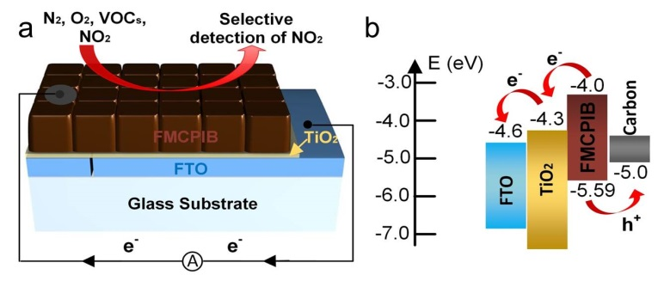
The development of portable devices for monitoring personalized healthcare, toxic gas emission and public space safety is driving a renaissance in solid-state sensor technologies.¹ In addition to metal oxide semiconductor, recently, the prominent feature of lead halide perovskite as one promising light harvester for many optoelectronic applications, some new features (including chemical sensing and interface charge properties) have also been reported,² which holds a great promise in widening the application of lead halide perovskite materials. Here, we present some perovskite based chemical sensors for chemical sensing without any applied external bias for the first time.³ As demonstration, a device consisting of non-passivated FA_{0.80}MA_{0.15}Cs_{0.05}PbI_{2.55}Br_{0.45} (FMCPIB) nanocrystals shows high selectivity and swift response and recovery time (t_{rs}=16.7 s, t_{rc}=126.1 s) for the detection of particle per million (ppm) concentrations of NO₂ with no obvious sensor response to other analyte gases at room temperature (30 ºC) (Fig. 1). This devices can be operated under self-powered mode (zero external bias or short-circuit mode) for chemical sensing of NO₂ under multiple kinds of light excitations (fluorescent lamp light or monochromic light with different wavelengths) at room temperature, where the light-generated power is used as the driving power. More interestingly, this self-powered devices remain operational for the detection of NO₂ as long as 1.7 hours in dark condition, revealing an appealing self-charging and storage feature inherited in FMCPI based chemical sensor devices. Besides, the devices can also be operated under 1 V of applied external voltage and the detection limit for NO₂ can reach as low as 0.2 ppm at room temperature. These distinctive features revealed on this FMCPIB based chemical sensor devices including room-temperature and self-powered operation, self-charging and storage ability, swift response and recovery time, and extraordinary selectivity for NO₂ detection make it as an excellent candidate in chemical sensor family with a great potential application in monitoring the toxic gas emission and public space safety.
Fig. 1. Schematic illustration of a FMCPIB based chemical sensor. a, Schematic of NO₂ gas sensing by the FMCPIB device. b, Energy level diagram of the FMCPIB device, showing photoexcited electron injection and hole extraction.

References
- Chen, H. Bo, R. Shrestha, A. Xin, B. Ma, Q. Nasiri, N. Zhou, J. Bernardo, I. D. Dodd, A. Saunders, M. Lipton-Duffin, J. White, T. Tsuzuki, T. Tricoli, A. (2018). NiO–ZnO Nanoheterojunction Networks for Room-Temperature Volatile Organic Compounds Sensing. Adv. Optical Mater., 1800677.
- Stranks, S. D. & Snaith, H. J. (2015). Metal-halide perovskites for photovoltaic and light-emitting devices. Nat. Nano., 10, 391-402.
- Chen, H. Zhang, M. Bo, R. Barugkin, C. Zheng, J. Ma, Q. Huang, S. Ho-Baillie, W. Y. A. Catchpole, R. K. Tricoli, A. (2018). Superior Self-Powered Room-Temperature Chemical Sensing with Light-Activated Inorganic Halides Perovskites. Small, 14, 1702571.

