A (Super) Bug's Life: Antimicrobial Particles as Next Generation Antimicrobial Strategies
Samuel Cheeseman¹, Sheeana Gangadoo¹, Russell J. Crawford¹, Torben Daeneke², Daniel Cozzolino¹, Aaron Elbourne^{1,*}, Vi Khanh Truong ^{1,*} and James Chapman^{1,*}

¹ Nanobiotechnology Laboratory, School of Science, College of Science, Engineering and Health, RMIT University, Melbourne, VIC 3001, Australia
² School of Engineering, RMIT University, Melbourne, VIC 3001, Australia
james.chapman@rmit.edu.au
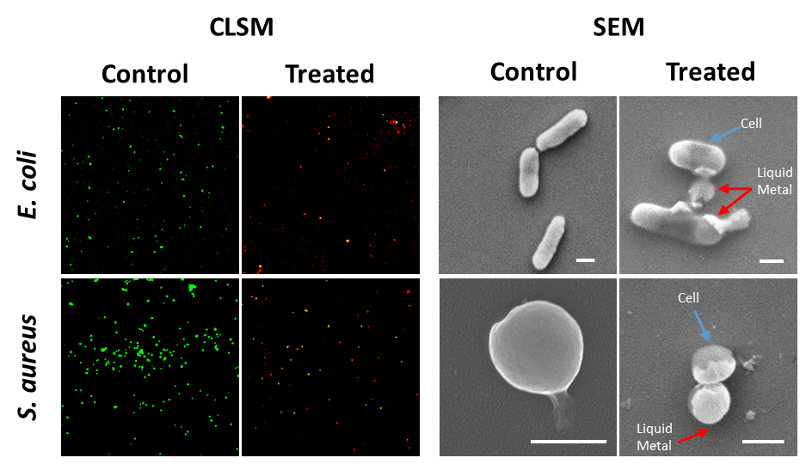
Antimicrobial resistance (AMR) is one of the most significant health-related issues of the 21st century which necessitates the need for alternative treatment technologies [1]. The toolbox of agents used to treat microbial infections is at a breaking point, where no new discoveries of antibiotics have come to fruition. This lack of discovery, coupled with poor management and use of antibiotics have resulted in AMR, a problem the World Health Organization says is now a global crisis. As a potential replacement to the antibiotic crisis, metal and metal oxide nanoparticles (NPs) have been studied. Additionally, antibacterial effects of metal ions have also been demonstrated to be effective, where gallium ions have shown displayed significant efficacy in the ability to kill microorganisms. However, there is limited research surrounding the interactions of gallium metal with bacteria. In this work, we demonstrate novel results to fill this gap showing the antibacterial activity of gallium micro-/nanodroplets against the Gram-positive, Gram-negative and Fungal strains. Additionally, we propose a novel antibacterial burst and release mechanism of the liquid metal droplets. The knowledge gained through this work will inform future designs of antibacterial technologies, also providing fundamental results on the interactions between bacteria and liquid metals.
Figure 1: Confocal laser scanning microscopy (CLSM) images showing predominately viable cells (green) in the control samples and inactivated cells (red) in the treated samples. Scanning electron microscopy (SEM) images highlighting the interactions between the gallium liquid metal droplets and E. coli and S. aureus.

References
[1[ K, Bush et. al., Nature Reviews Microbiology, 9, (2011) 894-896.

