Cobalamins as Reactive Surface Enhanced Raman Probes for the Detection & Quantification of Sulphite

Paul Denman¹, Kevin Jack³, James Blinco⁴, Idriss Blakey^{1,2}
¹Australian Institute of Bio-engineering & Nanotechnology University of Queensland, St. Lucia, Queensland 4072, Australia, ²Centre for Advanced Imaging, University of Queensland, St. Lucia, Queensland 4072, Australia, ³Centre for Microscopy and Microanalysis, University of Queensland, St. Lucia, Queensland 4072, Australia, ⁴Science and Engineering Faculty, Queensland University of Technology, Brisbane, Queensland, 4001, Australia

Surface Enhanced Raman Spectroscopy (SERS) has been shown to be a highly promising molecular sensing technique, especially in aqueous and biological applications due to high sensitivity, rich spectroscopic information and excellent water compatibility. Due to the nature of SERS, a noble metal substrate is required to achieve Raman signal amplification and gold nanoparticle (AuNP) aggregates can provide an easy to modify, and simple to synthesise substrate that provide excellent Raman signal enhancement. However, this system can have issues with further agglomeration and sedimentation which can be prevented through incorporation of aggregates into a polymer hydrogel substrate,¹ or slowed down by coating the particles with suitable molecular stabilises.² Direct SERS based sensing also has selectivity issues with molecular detection in complex mixtures, which can be overcome with the incorporation of a reactive probe such as a cobalamin that then targets the desired analyte – resulting in highly sensitive, selective detection.

Cobalamins have a rich chemistry that has been consistently investigated, chiefly relating to its biological role in the body. Here we show they also have a novel application as a reactive probe in an AuNP based SERS sensing system for the detection of sulphite. By first coating AuNPs with cyanocobalamin, followed by aggregation in order to generate high SERS enhancements and then addition of sulphite, we successfully demonstrate that this pH tuneable system can give a ratiometric SERS signal for the quantification of sulphite in complex solutions such as wine down to nano-molar concentrations.
SO₃
NaCl

Gold Nanoparticles (AuNPs)
+
Reaction of
cyanocobalamin with SO₃
Aggregation with high SERS enhancement
Cyanocobalamin
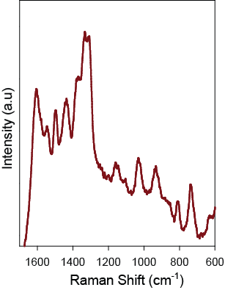
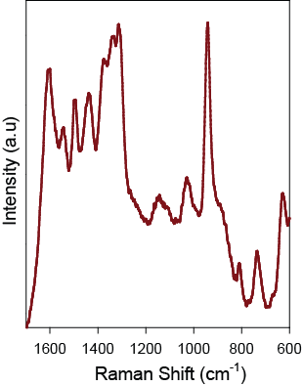

SO₃

Figure 1: Visual representation of cyanocobalamin incorporation into AuNPs, followed by aggregation with NaCl and the corresponding SERS signal change upon addition of sulphite.

1. Pastoriza-Santos, I.; Kinnear, C.; Pérez-Juste, J.; Mulvaney, P.; Liz-Marzán, L. M., Plasmonic polymer nanocomposites. Nature Reviews Materials 2018

2. Blakey, I.; Merican, Z.; Thurecht, K. J., A method for controlling the aggregation of gold nanoparticles: tuning of optical and spectroscopic properties. Langmuir 2013, 29 (26), 8266-74.

