Green synthesis of zeolitic imidazolate framework nanopowders and their water related applications

Mahdiar Taheri ^{A}, Takuya Tsuzuki ^{A,*}
^{A} Research school of Electrical, Energy and Materials Engineering, Australian National University, Canberra 2600, Australia
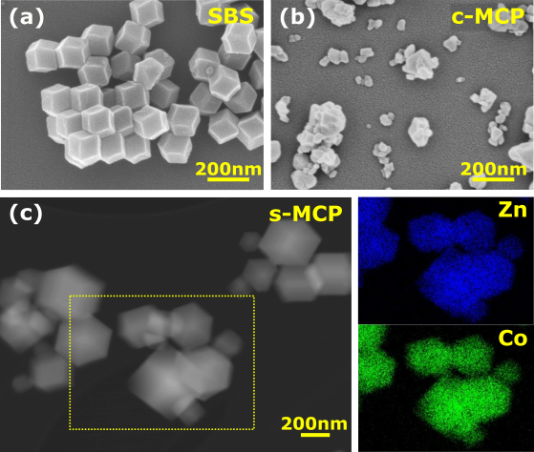
Introduction and aims
Zeolitic imidazolate frameworks (ZIFs), in particular ZIF-8 (made of Zn²⁺ and 2-methyilimidazolate) and cobalt-doped-ZIF-8, are found important for many energy and environmental applications. Although many nanofabrication methodologies to engineer MOFs have been investigated, most of these studies focused on the optimization of MOF's properties or on the clarification of their crystal structures. There are only a small number of studies that address their scalability and green synthesis, both of which are critical to their commercial applications. This study reports a detailed approach to the production of ZIF nanopowders from an inexpensive precursor, in a green, fast and scalable way, with a high yield and minimal waste for water related applications. In addition, we report a new approach to study the water stability of 0-100 at% cobalt-doped ZIF-8. Finally, the effects of the structural instability on some water based applications are discussed.
Fig.1 SEM images of ZIF-8 nanopowders synthesized via (a) methanol-based method and (b) mechanochemical conversion of ZnO; (c) STEM HAADF image of mechanochemically synthesized 50at% Co-doped-ZIF-8
Methods
Mechanochemical processing of ZnO nanoparticles and 2-methylimidazole in a stoichiometric molar ratio of 1:2 was performed to produce ZIF-8 nanoparticles. Cobalt-doped ZIF-8 nanopowders were also mechanochemically synthesised. Surface chemistry of mechanochemically converted ZIF-8 was studied by monitoring organic pollutant adsorption properties. Water stability of cobalt-doped ZIF-8 nanopowders was evaluated by combining many analytical techniques. Bactericidal properties of ZIF-8 nanoparticles were studied in comparison to ZnO nanopowders, under dark conditions.
Results & discussion
Mechanochemical processing resulted in the full and rapid conversion of ZnO nanopowders to well-dispersed ZIF-8 nanopowders of ca 80 nm in diameter. These particles had a very high specific surface area of 1,885 m²/g, close to that of the theoretical maximum of 1,947 m²/g, due to the low degree of agglomeration. The mechanochemically processed ZIF-8 nanopowders exhibited higher adsorption of organic pollutants on their external surface, compared to ZIF-8 nanopowders synthesized via a solution-based method. Successful mechanochemical synthesis of cobalt-doped ZIF-8 from 0 to 100 wt% doping level was also demonstrated. Unlike other synthesis methods, the mechanochemical method allowed the production of nano-scale ZIF particles with similar sizes, independent of cobalt-doping levels.
The water stability of cobalt-doped ZIF-8 was investigated by using mechanochemically produced ZIF particles with identical sizes (200-400 nm), in order to eliminate the effects of particle size on hydrolysis. It was reported in the past that ZIFs show excellent structural stability in water and thus ideal for aqueous applications. However, recent studies also found some evidence that ZIF-8 undergoes hydrolysis in water. This study found that ZIF-8 does decompose in water and that it is critical to analyse both filtered powders and the filtrate liquid systematically, in particular by using UV-Vis spectroscopy and thermogravimetric analysis, to quantitatively analyse the water stability of ZIF structures.
ZIF-8 nanopowders demonstrated higher antimicrobial properties in comparison to ZnO nanopowders, due to their instability in water and faster release rate of Zn²⁺ ions along with 2-methylimidazolate ions.
References
- Taheri, M. et al. (2019). Green scalable mechanochemical conversion of ZnO nanopowders to zeolitic imidazolate framework-8 (ZIF-8) nanopowders for fast dye adsorption, submitted.
- Taheri, M. et al. (2019). Water stability of cobalt doped ZIF-8: New approach to quantitative study. Submitted.
Contacts takuya.tsuzuki@anu.edu.au, mahdiar.taheri@anu.edu.au

