MEMS-based Photonic Coupler

M. Zawierta, J. Gurusamy, S. Swain, G. Putrino, D. Silva, A. Keating, L. Faraone, M. Martyniuk
Department of Electrical, Electronic and Computer Engineering
The University of Western Australia, Crawley, WA 6009, Australia
Over the past decade, optical switches have shown immense promise for large bandwidth with low optical loss and low power consumption signal switching for variety of applications linked to telecommunication networks and high-throughput computing [1]. Recently, a microelectromechanical system (MEMS) actuated vertical adiabatic coupler has been demonstrated to achieve optical coupling between different on-chip waveguides with an optical loss of ~0.5 dB [2]. The adopted methodology follows the concept depicted schematically in Fig. 1(a) where light is coupled from an on-chip waveguide into an overlaying MEMS-suspended waveguide adiabatically by electrostatically attracting the suspended waveguide towards the on-chip waveguide. The switching performance relied on the suspended optical waveguide ends tapering and terminating into sharp tips of ~100 nm in width to achieve low-loss transmission (not depicted in Fig. 1(a)), which requires advanced and expensive fabrication steps such as electron beam or deep ultraviolet lithography. In this contribution, we present a novel approach with modelled results that show similar performance using a process that removes the need for sub-100nm resolution lithography.

As depicted in Fig. 1(a), we present a concept of light switching between the on-chip and suspended waveguides deploying a gradual reduction in distance between them and modified waveguide geometry not requiring detrimental waveguide termination. We present finite difference time domain (FDTD) simulations performed using MEEP open source software demonstrating optical switching with transmission losses near 0.1 dB for bandwidth compatible with telecommunication bands as presented in Fig. 1(c). Experimental validation of the simulated performance is currently in progress.

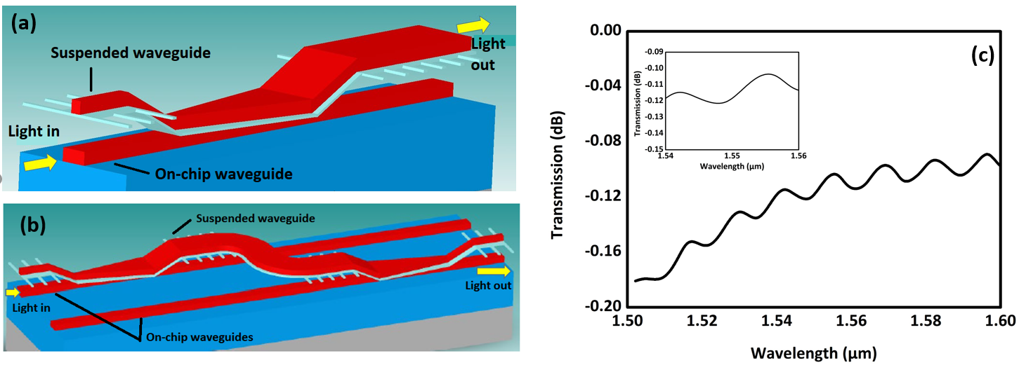
The investigated novel design of MEMS-based photonic coupling requires minimal energy consumption and is economic to manufacture using conventional lithographic processes. Widespread adoption into on-chip optical signal processing can be attained by adopting methodologies presented schematically in Fig. 1(b), which illustrates on-chip optical waveguide switching using a suspended bridging waveguide with both ends being mechanically pulled downward to guide the light between the two on-chip parallel waveguides.
Figure 1. (a) Schematic 3D view of the investigated MEMS adiabatic coupler. Light propagating from the bottom on-chip waveguide is coupled into the overlaying suspended waveguide using evanescent coupling taking place only when the top suspended waveguide is attracted electrostatically towards the bottom on-chip waveguide. (b) Schematic implementation for optical switching between two on-chip waveguides using a suspended MEMS bridging waveguide actuated independently over each of the on-chip waveguides. (c) FDTD modelled optical transmission loss as a function of wavelength predicted for the coupling concept shown in (a).
References
- X. Tu, C. Song, T. Huang, Z. Chen and H. Fu (2019). micromachines, 10, 51.
- T. J. Seok, N. Quack, S. Han, R. S. Muller and M. C. Wu (2016). Optica, 3, 64-70.
Corresponding author email-id - shubhashree.swain@research.uwa.edu.au

