Ultrasonic spray pyrolysis of doped tin oxide films for transparent electrode applications

Jaewon Kim^{A}, Enrico Della Gaspera^{A}
^{A}School of Science, RMIT University, Melbourne, Australia

Transparent conducting oxides (TCOs) have a wide range of applications owing to their high visible transmittance and electrical conductivity, which make them suitable within solar cells, touchscreen displays, LEDs, gas sensors and heat mirrors [1]. Among all the transparent conductive oxides, tin dioxide (SnO₂) doped with fluorine (F) or antimony (Sb) is very attractive because it combines excellent functional properties (high conductivity, optical transmittance) with additional properties including chemically inertness, resistance to high temperatures and overall lower cost compared to the industry standard ITO (indium tin oxide) [2]. Doped SnO₂ can be synthesized by various techniques such as thermal evaporation, sputtering, chemical vapor deposition, sol–gel dip coating and spray coating. Sputtering deposition, physical vapor deposition system, is the mostly common method used to achieve high-quality SnO₂ thin films. However, vacuum-based techniques have significant disadvantages, including the need for high vacuum system, slow deposition speed, expensive equipment, and substrate damage by plasma [3]. In contrast, spray coating offers an inexpensive, simple process to fabricate TCO thin films over large areas, and with precise compositional control. In this talk, I will present the deposition of SnO₂ films doped with antimony and fluorine using ultrasonic spray pyrolysis. A solution containing both tin and dopant precursors is delivered to a hot substrate through an ultrasonic spray nozzle. The decomposition of metal precursors on the hot substrates triggers the formation of the metal oxide films. A comprehensive study of the effect of deposition parameters – solution flow rate, substrate temperature, gas pressure, post-annealing, doping concentration – will be presented, and eventually the optimal conditions for achieving smooth, dense, highly conductive and highly transparent doped SnO₂ films will be shown. Thorough characterizations of the SnO₂ films including SEM, XRD, XPS, UV-Vis-NIR spectroscopy and electrical conductivity are performed in order to correlate the deposition parameters with the properties of the SnO₂ films. Champion coatings achieving conductivities of 1.02x10⁵ S/m with an overall visible transparency of >85% are demonstrated, which are directly competitive with vacuum-deposited TCOs. This research enables the fabrication of transparent conducting coatings which possess the same morphological and functional properties of those deposited with vacuum-based processes, but are deposited with simple and scalable solution-based methods.

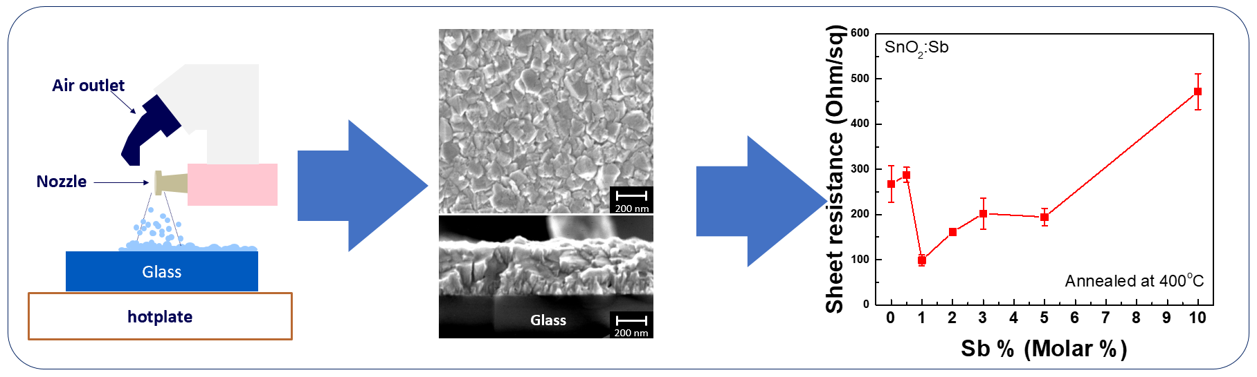

Figure 1. An Illustration of experimental procedure of SnO₂:Sb by spray pyrolysis and its result of electrical property.

References
- Calnan, S. et. al., Thin Solid Films, 2010, 518, (7), pp. 1839-1849.
- Tatar, D. et. al., Pramana, 2012, 79, (1), pp. 137-150
- Ali, A.H. et. al., Applied Surface Science, 2018, 443, pp. 544-547

