Drying of graphene hydrogel fibers for capacitive energy storage

Yuan Chen^{A}
^{A}School of Chemical and Biomolecular Engineering, The University of Sydney, Sydney, Australia

Graphene microfibers exhibit excellent performance for capacitive energy storage.¹⁻⁵ Graphene hydrogel fibers are usually first assembled from graphene oxide (GO) nanosheets via a space-confined hydrothermal treatment, followed by a drying process to yield compact yet highly porous graphene microfibers. The dimension (i.e., diameter and length) of reduced GO (rGO) hydrogel fibers decrease significantly (up to 10 times) during drying accompanied by complex internal structural transforms. However, no studies have investigated this critical drying process in detail. Here, we present a comprehensive study to fill this knowledge gap by linking the drying conditions of rGO hydrogel fibers with the electrochemical properties of resulting graphene microfibers. Five drying conditions involving different temperatures, pressures, and solvent exchanging conditions were compared. Solvent removal rates and interfacial forces were found to substantially altered the internal structures of resulting graphene microfibers, and subsequently, leading to dramatically different electrochemical properties. A slow solvent removal rate and large liquid-solid interfacial forces are critical for achieving well-aligned rGO nanosheets in microfibers with excellent pore connectivity, which are crucial to electrolyte ion transport. Besides, trapping solvated ions within micropores among rGO nanosheets is also beneficial for ion transport and adsorption/desorption. These results indicate that the selection of proper solvents, drying temperatures, and pressures are critical to obtaining graphene microfibers with excellent electrochemical properties. The new fundamental insights into the assembly of GO nanosheets into 1D graphene microfibers also provide useful guides for achieving controllable assembly of 2D materials into desirable nanoarchitectures for energy storage applications and beyond.

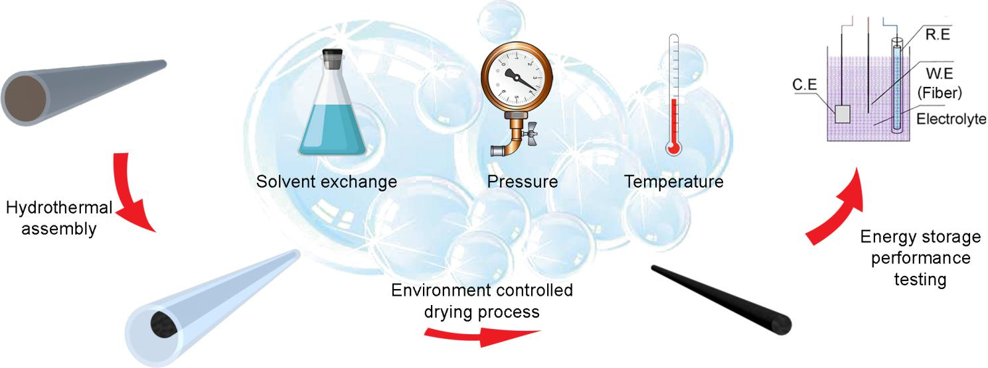

References
- Jiang, W.; Chen, Y.; et al. (2016). Space-confined assembly of all-carbon hybrid fibers for capacitive energy storage: realizing a build-to-order concept for micro-supercapacitors; Energy & Environmental Science, 9, 611-622
- Zhai, S; Chen, Y.; et al. (2017) Hydrothermal assembly of micro-nano-integrated core-sheath carbon fibers for high-performance all-carbon micro-supercapacitors; Energy Storage Materials, 9, 221-228
- Zhai, S; Chen, Y.; et al. (2018) Ultrafast hydrothermal assembly of nanocarbon microfibers in near-critical water for 3D microsupercapacitors, Carbon, 132, 698-708
- Zhai, S; Chen, Y.; et al. (2018) Nano-RuO2-decorated holey graphene composite fibers for micro-supercapacitors with ultrahigh energy density, Small, 14(29) 1800582
- Wang, C; Chen, Y.; et al. (2019) A core-sheath holey graphene/graphite composite fiber intercalated with MoS2 nanosheets for high-performance fiber supercapacitors, Electrochimica Acta, 305, 493-501.

