Developing peptide receptor radionuclide therapies (PRRT) for personalised cancer therapy

Simon Puttick^{A}, Charlotte Williams^{A}, Jason Ross^{A}, Yi Jin Liew^{A}, Kathy Surinya^{A}, Wioletta Kowalczyk^{A}, Jerome Barley^{B}, Michael Fay^{B}, Danielle Meyrick^{B}, Nat Lenzo^{B} and Stephen Rose^{A}

^{A}Probing Biosystems Future Science Platform, Commonwealth Scientific and Industrial Research Organisation, Brisbane, Australia; ^{B}GenesisCare, Sydney, Australia.

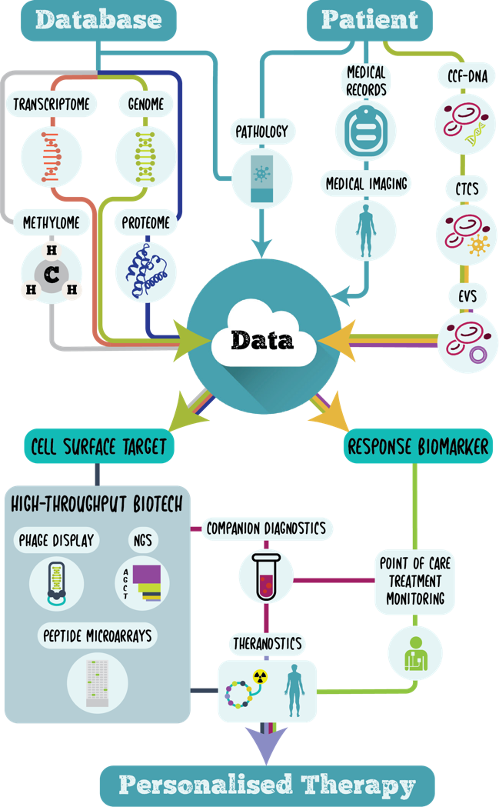
Peptide receptor radionuclide therapy (PRRT) is changing the face of cancer care for advanced metastatic cancers^{1,2}. The paradigm relies on the combination of a disease specific cell-surface biomarker and a high affinity ligand that can be radiolabeled with positron, beta or alpha emitting radiometals.

CSIRO have now partnered with GenesisCare to drive the development of new PRRTs for 32 different cancers from concept to clinic.

By integrating and normalising large public domain molecular biology databases and implementing our bioinformatics selection algorithms, we have isolated over 300 cell surface targets of interest.

Using peptide phage display techniques monitored by next generation sequencing we are isolating peptide ligands to 31 targets and optimising affinity through the use of high throughput peptide microarrays.

In this presentation I will outline our research program highlighting recent outcomes from our data-driven approach to lead candidate optimization.

References

1. Hofman, M.S., et al. [177Lu]-PSMA-617 radionuclide treatment in patients with metastatic castration-resistant prostate cancer (LuPSMA trial): a single-centre, single-arm, phase 2 study. The Lancet Oncology 19, 825-833 (2018).
2. Strosberg, J., et al. Phase 3 Trial of 177Lu-Dotatate for Midgut Neuroendocrine Tumors. New England Journal of Medicine 376, 125-135 (2017).

