Interatomic force laws that evade dynamic measurement

John E Sader^{A,B}, Barry D Hughes^{B}, Ferdinand Huber^{C}, Franz J Giessibl^{C}
^{A}ARC Centre of Excellence in Exciton Science, The University of Melbourne, Victoria 3010, Australia;
^{B}School of Mathematics and Statistics, The University of Melbourne, Victoria 3010, Australia;
^{C}Institute of Experimental and Applied Physics, University of Regensburg, 93053 Regensburg, Germany.

Synopsis
Measurement of the force between two atoms is performed routinely using the atomic force microscope. In this talk, we show that the shape of this interatomic force law directly regulates this capability. Rapidly varying interatomic force laws, which are common in nature, can corrupt their own measurement.

Introduction
The success of the atomic force microscope (AFM) in quantifying structure and forces—at molecular and atomic levels—hinges on the extreme precision with which the response of its force sensing microcantilever can be measured. Dynamic measurements lead to a convoluted relationship between the interaction force and the measured resonant frequency, amplitude and/or phase of the cantilever’s motion. These observables are converted into force that the cantilever experiences through a range of established mathematical algorithms. This has led to tremendous advances in capability at the atomic scale, including the quantification and direct measurement of chemical forces, molecular stiffness and friction.

Results
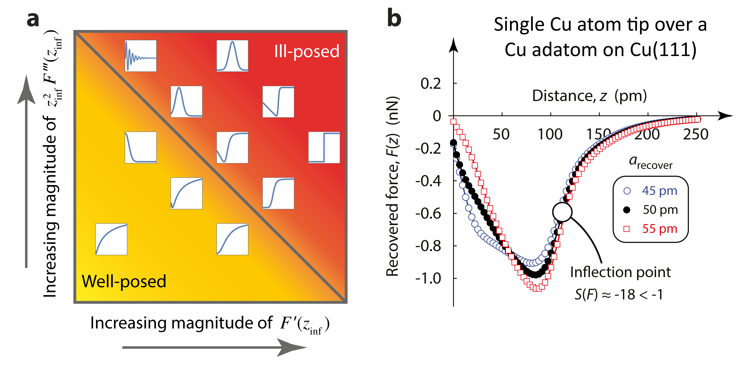
Figure 1. a) Master plot of practical force laws, F(z), of different shape (white boxes) and their position in the ill-posedness phase space. b) Atomically resolved measurements of a single-atom Cu tip over a Cu adatom on a Cu(111) surface at 5.9 K in ultrahigh vacuum.
Frequency-modulation (FM) AFM is typically used for atomically-resolved measurements. In this operational mode, the cantilever is self-excited in a feedback loop that guarantees it oscillates on resonance. Because the cantilever in FM–AFM always oscillates at finite amplitude—over which the interaction force between tip and sample is measured—it inherently produces a blurring effect (which has not been explored previously). In this talk, we show that FM force spectroscopy can be ill-posed in many practical measurements (due to blurring), with the shape of the force law directly controlling this property; Fig. 1a summarises our principal findings. The observed ill-posedness is caused by a rapid jump in the force. This motivates development of an ‘inflection point test’:
$$S\left(F\right)≡\frac{z_{inf}^{2}}{4}\frac{F^{‴}\left(z_{inf}\right)}{F^{'}\left(z_{inf}\right)}≳-1,$$
where $F(z)$ is the force law and $z_{inf}$ is the infection point position. This S-factor can be easily used by AFM practitioners to gauge the ill-posedness of any force measurement—they may then adjust the chosen oscillation amplitude, a, to eliminate ill-posed behaviour. The utility of the S-factor is illustrated in Fig. 1b, which shows an atomically resolved force measurement in ultrahigh vacuum.

The authors gratefully acknowledge support of the ARC Centre of Excellence in Exciton Science (CE170100026) and the Australian Research Council Grants Scheme.

References
- Sader, J. E., Hughes, B. D., Huber, F. & Giessibl, F. J. (2018) Interatomic force laws that evade dynamic measurement, Nature Nanotech., 13, 1088–1091.

