Distinct modes of filament formation in Niobium Oxide

Shimul Kanti Nath ^{A*}, Sanjoy Kumar Nandi^{A}, Assaad El Helou^{B}, Shuai Li^{A}, Peter E. Raad^{B}, and Robert Elliman^{A}
^{A}Department of Electronic Materials Engineering, Research School of Physics, The Australian National University, CANBERRA, ACT 2601, AUSTRALIA; ^{B}Department of Mechanical Engineering, Southern Methodist University, DALLAS, TX 75205, USA
Characteristic resistance changes are observed in two-terminal metal-oxide-metal (MOM) structures when subjected to large electric fields or current densities and are of interest as the basis of nonvolatile memory and neuromorphic computing devices [1]. These resistance changes are often mediated by filamentary conduction, either in the form of a semi-permanent filament created by compositional changes in the oxide or as a transient filament created by inhomogeneous current or field distributions (e.g. current bifurcation). Knowledge of the filament location and morphology, and how these are affected by device geometry and material processing is important for understanding device operation and scaling. For example, enhanced filament formation is expected around the edges of cross-point devices due to local field enhancement or variations in oxide thickness. In contrast, the formation of high current density filaments is predicted to be at the center of the device structure as a result of thermal instability in a uniform material with no weak spots [2]. To gain an understanding of such effects it is desirable to have a simple, robust method of detecting and mapping filaments and to use this to study the statistics of filament formation.

We have detected the location of conducting filaments using a new technique based on thermal denaturing of a thin photoresist layer [3]. The efficiency of this approach is demonstrated by applying it to MOM cross-point structure comprised of an Au (25 nm)/Nb (5 nm) /NbO_{x} (45 nm)/Pt (25 nm) heterostructure, with cross point areas of 4-400 µm². In-situ thermoreflectance measurements were also performed during electroforming step without the photoresist layer and results are compared with the method based on thermal denature of the photoresist layer. Statistical analysis of the filaments shows that forming generally produces one dominant filament but that the spatial distribution of the filaments depends on device parameters such as film’s conductivity and two distinct modes of filament formation can be observed which was further confirmed by thermal imaging. These results demonstrate the importance of filament mapping for understanding the relationship between device parameters and performance and highlight the utility of identifying and mapping conductive filaments.
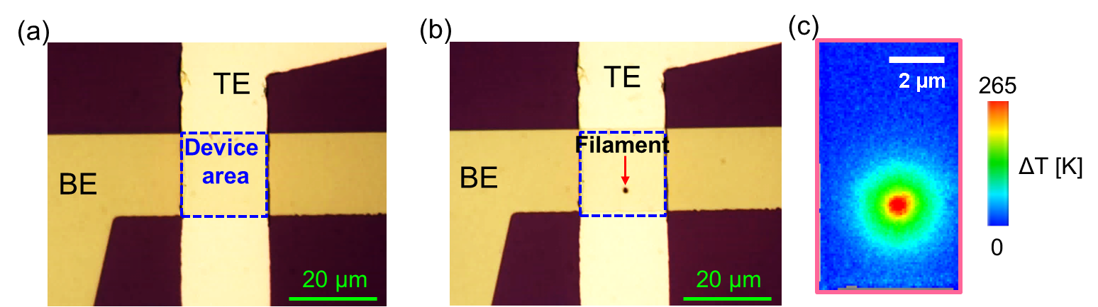
Figure 1: Optical microscope images of the same device before (a) and after (b) the electroforming process. The dark spot on the device after forming indicates the location of a conducting filament. (c) In-situ thermoreflectance measurements showing current bifurcation.
References
- Burr, W. Shelby, R. M. Sebastian, A. Kim, S. Kim, S. Sidler, S. Virwani, K. Ishii, M. Narayanan P. & Fumarola, A. (2017). Neuromorphic computing using non-volatile memory. Adv. Phy. X 2 (1), 89-124.
- Goodwill, J. M. Ramer, G. Li, D. Hoskins, B. D. Pavlidis, G. McClelland, J. J. Centrone, A. Bain J. A. & Skowronski, M. (2019). Spontaneous current constriction in threshold switching devices. Nat. Comm., 10 (1), 1628.
- Nath, S. K. Nandi, S. K. Li S. & Elliman, R. G. (2019). Detection and spatial mapping of conductive filaments in metal/oxide/metal cross-point devices using a thin photoresist layer. Appl. Phys. Lett., 114 (6), 062901.
*Corresponding author email: Shimul.Nath@anu.edu.au

