Fidelity benchmarks for two-qubit gates in silicon¹

W. Huang^{A}, C. H. Yang^{A}, K. W. Chan^{A}, T. Tanttu^{A}, B. Hensen^{A}, R. C. C. Leon^{A}, M. A. Fogarty^{A},
J. C. C. Hwang^{A}, F. E. Hudson^{A}, K. M. Itoh^{B}, A. Morello^{A}, A. Laucht^{A} & A. S. Dzurak^{A}

^{A}Centre for Quantum Computation and Communication Technology, School of Electrical Engineering and Telecommunications, The University of New South Wales, Sydney, Australia;
^{B}School of Fundamental Science and Technology, Keio University, Hiyoshi, Yokohama, Japan

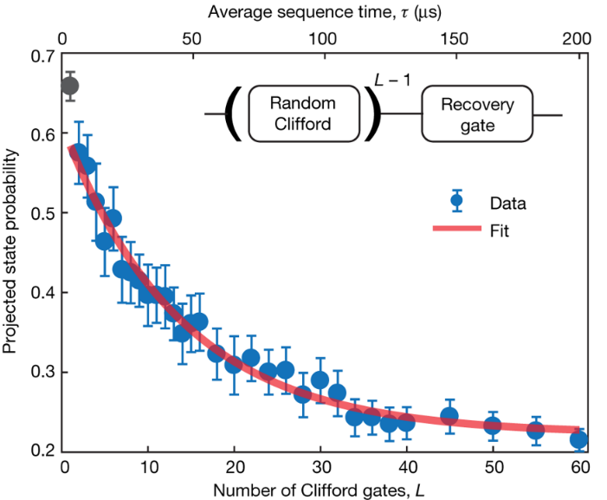
Universal quantum computation will require qubit technology based on a scalable platform [2], together with quantum error correction protocols that place strict limits on the maximum infidelities for one- and two-qubit gate operations. Although various qubit systems have shown high fidelities at the one-qubit level, the only solid-state qubits manufactured using standard lithographic techniques that have demonstrated two-qubit fidelities near the fault-tolerance threshold have been in superconductor systems. Silicon-based quantum dot qubits are also amenable to large-scale fabrication and can achieve high single-qubit gate fidelities (exceeding 99.9 per cent) using isotopically enriched silicon. Two-qubit gates have now been demonstrated in a number of systems[3-5], but as yet an accurate assessment of their fidelities using Clifford-based randomized benchmarking, which uses sequences of randomly chosen gates to measure the error, has not been achieved. Here, for qubits encoded on the electron spin states of gate-defined quantum dots, we demonstrate Bell state tomography with fidelities ranging from 80 to 89 per cent, and two-qubit randomized benchmarking with an average Clifford gate fidelity of 94.7 per cent and an average controlled-rotation fidelity of 98 per cent. These fidelities are found to be limited by the relatively long gate times used here compared with the decoherence times of the qubits. Silicon qubit designs employing fast gate operations with high Rabi frequencies, together with advanced pulsing techniques, should therefore enable much higher fidelities in the near future.

We thank S. Bartlett, R. Harper, L. M. K. Vandersypen, T. D. Ladd and N. C. Jones for discussions. We acknowledge support from the US Army Research Office (W911NF-13-1-0024 and W911NF-17-1-0198), the Australian Research Council (CE170100012), and the NSW Node of the Australian National Fabrication Facility. The views and conclusions contained in this document are those of the authors and should not be interpreted as representing the official policies, either expressed or implied, of the Army Research Office or the US Government. The US Government is authorized to reproduce and distribute reprints for Government purposes notwithstanding any copyright notation herein. B.H. acknowledges support from the Netherlands Organization for Scientific Research (NWO) through a Rubicon Grant. K.M.I. acknowledges support from a Grant-in-Aid for Scientific Research by MEXT, NanoQuine, FIRST, and the JSPS Core-to-Core Program.

References
- Huang, W. et al., Fidelity benchmarks for two-qubit gates in silicon. Nature 569, 532–536 (2019)
- Loss, D. & DiVincenzo, D. P. Quantum computation with quantum dots. Phys. Rev. A 57, 120–126 (1998).
- Veldhorst, M. et al. A two-qubit logic gate in silicon. Nature 526, 410–414 (2015).
- Watson, T. F. et al. A programmable two-qubit quantum processor in silicon. Nature 555, 633–637 (2018).
- Zajac, D. M. et al. Resonantly driven cnot gate for electron spins. Science 359, 439–442 (2018).

