Liposomes as fuel for micromotors

Federico Mazur^{A,B}, Marina Fernández-Medina^{A}, Rona Chandrawati^{B}, Brigitte Städler^{A}

^{A}Interdisciplinary Nanoscience Center (iNANO), Aarhus University, Aarhus, Denmark; ^{B}School of Chemical Engineering and Australian Centre for NanoMedicine (ACN), The University of New South Wales, Sydney, Australia

Introduction
Micromotors are objects capable of autonomous movement in liquid environments. Their applications include environmental decontamination, building blocks for sensors and biomedical delivery vehicles, among others. Micromotors can be driven by a variety of mechanisms including the most commonly used H₂O₂ or the disintegration of their building blocks (Fernández-Medina et al. (2019)). Complementarily, we developed a micromotor fuelled by a non-toxic material, liposomes (Mazur et al. (2017)), where self-propulsion is triggered via membrane solubilization by surfactants (Triton X-100 (TX) or bile) or membrane hydrolysis using enzymes (phospholipase A₂ (PLA₂)). Further development could lead to a method for targeted cargo-delivery in biomedical applications.
Aims
We aimed to: (i) compare micromotor mobility when triggered by TX, bile and PLA₂, (ii) explore liposome-liposome fusion as a trigger for self-propulsion, and (iii) assess micromotor mobility when increasing fuel availability.
Methods
The locomotion of micromotors was tested using microfluidic chips mounted on an inverted microscope. Movies were recorded following addition of the trigger, from which trajectories could be extracted and a Mean Square Displacement analysis carried out.
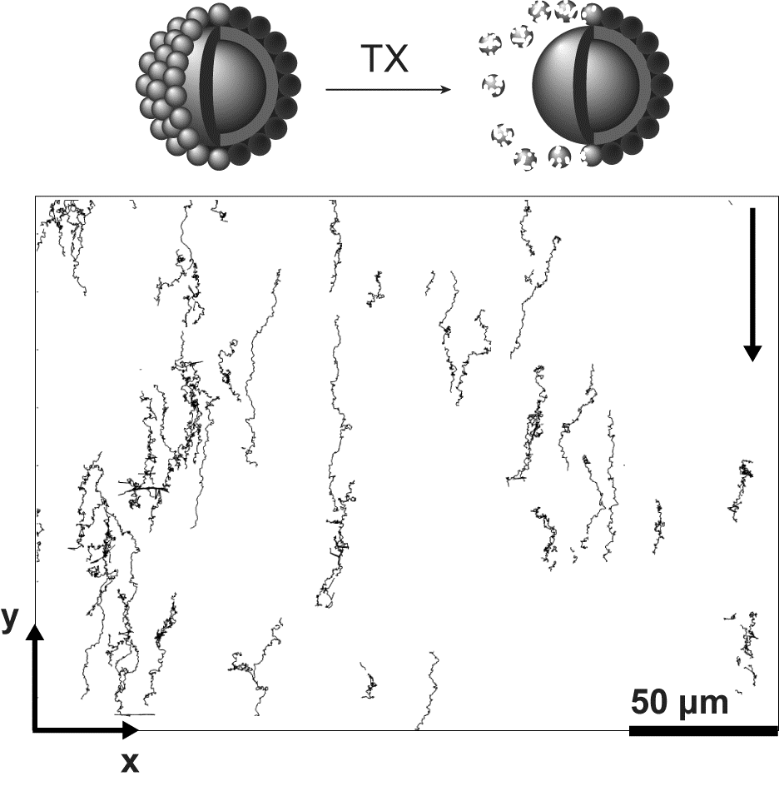
Results
Micromotor directional motion with average velocities of 1.0 and 1.7 μm s⁻¹ was observed when using TX (Fig. 1) and bile, respectively. PLA₂ and liposome fusion led to a reduction in random motion of the micromotor. None of the triggers resulted in directional motion when increasing fuel availability.
Discussion
Self-propulsion using TX as a trigger is believed to be caused by an asymmetry in the environment close to the micromotor. Locomotion using bile as a trigger was attributed to liposome shrinkage due to osmotically driven water efflux. The reduced motion using PLA₂ is believed to be caused by the lag-burst behaviour of the enzyme. The mobility decrease via liposome-liposome fusion was attributed to the increase in surface roughness of the micromotor.
Fig. 1 – Micromotor trajectories using TX as a trigger
Conclusion
A non-toxic fuelled micromotor has been proposed, which could open new avenues for cargo-delivery applications in the biomedical field.

References
- Fernández-Medina, M.; Qian, X. M.; Hovorka, O.; Städler, B. (2019) Disintegrating polymer multilayers to jump-start colloidal micromotors. Nanoscale, 11, 733-741.
- Mazur, F.; Bally, M; Chandrawati, R.; Städler, B. (2017) Liposomes and lipid bilayers in biosensors. Adv. Colloid Interfac. Sci., 249, 88-99.

Corresponding author: bstadler@inano.au.dk

