**Graphene metamaterials and functional devices**

*Baohua Jia, Han Lin, Keng-Te Lin*

*Centre for Translational Atomaterials, Faculty of Science, Engineering and Technology, Swinburne University of Technology, John Street, Hawthorn, Victoria 3122, Australia*

**Introduction**

Metamaterials comprising alternating graphene and dielectric layers are artificially structured materials designed to attain extremely high optical responses. Graphene-based metamaterials with layered artificial structure can enhance optical modulation; thus, theoretical studies have suggested that these materials can be useful in diverse applications. However, the fabrication of graphene-based metamaterials remains significantly challenging due to the inaccurate control and sophisticated transfer process of conventional mechanical exfoliation and deposition methods, restricting experimental demonstrations to only a few examples.[1]

**Results and discussion**

Fig. 1 Schematic of graphene metamaterials and the laser conversion process.

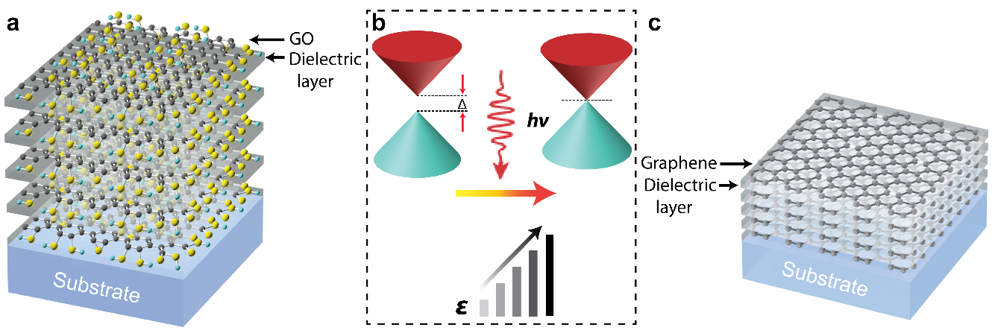

In this paper, we report a low-cost solution-phase method that generates a multilayered metamaterial consisting of alternating monolayer graphene oxide (GO)/graphene and dielectric layers without a transfer step. The single-step method produces metamaterial on diverse substrates with arbitrary surfaces, shapes, and sizes. The quality of the metamaterial is independent of the number of layers and surface area up to 100 layers. The surface roughness in the overall metamaterial thickness can be maintained at 2 nm, which is comparable to that obtained by state-of-the-art vacuum deposition techniques. In addition, laser-mediated photoreduction can convert GO to graphene and effectively decrease the bandgap of the graphene-based metamaterial (Figure 1) by removing the oxygen-functional groups. Such graphene metamaterials pave the way to multifunctional integrated devices due to their exceptional mechanical, thermal, optical, and electrical properties not available in conventional materials. This article explores the optoelectronic applications of graphene metamaterials by using the direct laser printing (DLP) method.[2] Our results demonstrate the great potentials of graphene metamaterial films as an emerging integratable platform for ultrathin, light-weight and flexible photonic devices towards all-optical communications, microscopic imaging and energy storage applications.[3-6]

**References**

1. Chang, Y.-C., Liu, C.-H., et al (2016), Nature Communications**,** 7, 10568.
2. Lin, H., Jia, B., Gu, M., (2011), Optics letters 36, 406-408.
3. Zheng, X., Jia, B., Chen, X., Gu, M., (2014), Adv. Mater. 26, 2699-2703.
4. Zheng, X., Jia, B., Lin, H., Qiu, L., Li, D., Gu, M., (2015), Nature Communications, 6, 8433.
5. Lin, H., Sturmberg, B. C. P. et al, (2019), Nature Photonics, 13, 270–276.
6. Yang, Y., Lin, H., et al, (2019), ACS Photonics 6 (4), 1033–1040.

**Acknowledgement**

This work is supported by Australian Research Council through the Discovery Project scheme (DP150102972, DP190103186) and Industrial Transformation Training Centres scheme (IC180100005).