Tailoring Directional Scattering of Second-Harmonic Generation from
(111)-GaAs Nanoantennas
J. Sautter^{A,B}, L. Xu^{C}, A. Miroshnichenko^{C}, Mykhaylo Lysevych^{A}, I. Volkovskaya^{D}, D. Smirnova^{A,D}, R. Camacho-Morales^{A}, Khosro Zangeneh Kamali^{A}, F. Karouta^{A}, K. Vora^{A}, H. H. Tan^{A}, Martti Kauranen^{E}, Isabelle Staude ^{B}, C. Jagadish^{A}, and D. N. Neshev^{A}, and M. Rahmani^{A}

^{A} Research School of Physics, The Australian National University, Canberra, ACT 2601 Australia; ^{B} Institute of Applied Physics, Abbe Center of Photonics, Friedrich Schiller University Jena, 07745 Jena, Germany; ^{C}School of Engineering and Information Technology, University of New South Wales, Canberra, ACT 2600, Australia; ^{D} Institute of Applied Physics, Russian Academy of Sciences, Nizhny Novgorod 603950, Russia; ^{E}Photonics Laboratory, Physics Unit, Tampere University, PO Box 692, FI-33014, Tampere University, Finland

The group of zincblende III-V semiconductors have recently been presented as promising materials for second harmonic generation (SHG) at the nanoscale. However, major obstacles to push the technology towards practical applications are the limited control over directionality of the SH emission and especially zero forward/backward radiation.¹⁻³ This issue is commonly referred to as off-diagonal emission in the literature. Here we present a novel approach in which the crystal axis is rotated by nanoantennas fabricated from a (111)-cut wafer.¹ For our (111)-antennas, the tetrahedral bonding leads to one of the bonds pointing upwards and the three other bonds spreading out in a projected 120° angle, leading to a three-fold symmetry. Figure 1a demonstrates the experimentally measured SHG from several antennas dimeters (with height of 400 nm) for an excitation wavelength of 1550nm. As can be seen, the conversion efficiency is nearly equal for the different polarizations for nanoantennas, interestingly. The three diameter ranges that exhibit peaks are due to various mode decompositions that can be found in Ref. [1]. The most intriguing feature of the nanoantennas is the capability to vary the radiation SH patterns at constant multipole character. Figure 1b displays the SHG radiated from a nanoantenna of r = 320nm. Top panel displays the projection, i.e the back-focal plane (BFP) image, in forward-direction of SHG emission. The area inside the black circles corresponds to the lightcone visible through the collecting objective and therefore to the experimental BFP images displayed in the middle panel. When the polarization of the pump is rotated, the radiation patterns clearly varies. Figure 1b, bottom panel, displays the multipole expansion of the nonlinear currents for this nanoantenna. Excitedly, it is exactly the same for all three, and indeed any, pump polarization. This feature is not only intriguing from a scientific point of view but also offers possible applications of polarization dependent beam steering at constant efficiency.
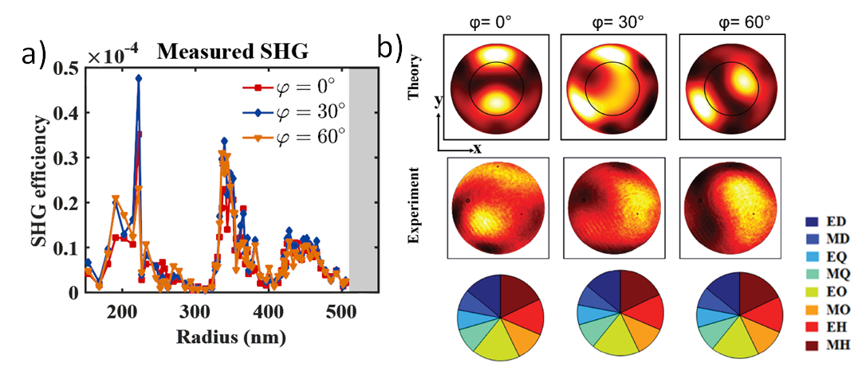
Figure 1. (a) Experimentally measured SHG efficiencies for cylindrical nanoantennas of varying radii and polarizations. (b) SHG from a (111)-GaAs nanoantenna with h=400nm and r=320nm for pump polarizations of φ = 0°, φ = 30° and φ = 60°, where top panel and middle panel show simulated and experimentally measured back focal plane images in forward direction, respectively. The black circles in top panel show the angular range collected in experiments. Bottom panel shows the multipole expansion of the nonlinear currents.
References
- Sautter, J., Xu, L., Miroshnichenko, A., Lysevych, M., Volkovskaya, I., Smirnova, D., Camacho, R., Kamali, K., Karouta, F., Vora, K., Tan, H., Kauranen, M., Staude, I., Jagadish, C., Neshev, D. and Rahmani, M. (2019). Tailoring second-harmonic emission from (111)-GaAs nanoantennas. Nano Lett. 6, 3905-3911.
- Liu, S., Sinclair, M., Saravi, S., Keeler, G., Yang, Y., Reno, J., Peake, G., Setzpfandt, F., Staude, I., Pertsch, T., Brener, I. (2016). Resonantly enhanced second-harmonic generation using III–V semiconductor all-dielectric metasurfaces. Nano Lett.16, 5426–5432.
- Marino, G., Gigli, C., Rocco, D., Lemaître, A., Favero, I., De Angelis, C., Leo, G. (2019). Zero-order second harmonic generation from AlGaAs-on-insulator metasurfaces. ACS Photon. 6, 1226–1231.

