NanoZymes as an alternative antibacterial to conventional antibiotics

Pyria Rose Divina Mariathomas^{A}, Mandeep Singh^{A}, Rajesh Ramanathan^{A} & Vipul Bansal^{A}
^{A}NanoBiotechnology Research Laboratory, Sir Ian Potter NanoBioSensing, School of Science, RMIT University, Melbourne, VIC 3001, Australia
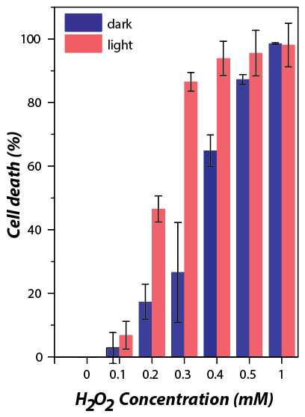
Introduction
Antimicrobial resistance (AMR) is a growing concern across the globe. Each year, antibiotic resistant microbes cause at least 2,049,442 illnesses 700,000 deaths (globally). Therefore, there is a growing urgency to search for a new generation of antimicrobial agents that are constructive. Nanotechnology offers a fantastic solution in the form of nanomaterials performing as nano-antimicrobial for fighting the multi-drug resistant microbial infections, acting as an alternative to conventional antibiotics.

Aim
The current research focuses on the synthesis of 2D Iron sulfide (FeS) nanosheets and explores its enzyme-mimicking catalytic behaviour to enhance the production of reactive oxygen species to kill bacteria.
Fig. Antibacterial activity of FeS nanosheets in the
presence of H₂O₂ under dark and light conditions.

Results and Discussion
- A facile method to fabricate high surface area, magnetic FeS nanosheets has been developed.
- The FeS nanosheets show high enzyme-mimicking catalytic behaviour.
- The rich optical property of FeS allows enhanced photoinduced production of reactive oxygen species (ROS) that results in efficient killing of bacteria.
- The ability to fine tune the catalytic activity of the enzyme-mimicking 2D FeS reduces the amount of nanomaterial required to µg/ml concentrations and H₂O₂ to sub mM concentrations while increasing the efficiency of bacterial killing.

Impact to society
- Efficient antibacterial system to tackle AMR.
- Visible light used as an external trigger to modulate killing of bacteria.
- Viable alternative for antibiotics.
- Improves quality of life.

References

Aminov, R. I. (2010). A Brief History of the Antibiotic Era: Lessons Learned and Challenges for the Future. Front. Microbiol. 1: 134.

Marlieke et al. (2016).Will 10 Million People Die a Year due to Antimicrobial Resistance by 2050?. PLoS Med.

Karim et al. (2018). Visible-Light-Triggered Reactive-Oxygen-Species-Mediated Antibacterial Activity of Peroxidase-Mimic CuO Nanorods. ACS Appl.Nano Mater.,1 (4), pp 1694–1704.

