Energy storage in thin film graphene-based supercapacitors as a function of the accessible surface area

Nunzio Motta^{A}, Michael Horn^{A}, Deepak Dubal^{A}, Jennifer MacLeod^{A}, Jinzhang Liu^{B}

^{A}School of Chemistry, Physics, and Mechanical Engineering, Queensland University of Technology, Brisbane 4001, QLD, Australia
^{B}School of Materials Science and Engineering, Beihang University, Beijing 100191, China.

Supercapacitors are an emerging energy storage technology that is competing with Li-ion batteries in the global market. A supercapacitor combines the properties of a traditional battery and a capacitor in a single component, with the ability of being fully charged in minutes and to release the energy quickly when required by the application. Supercapacitors have higher power density and much longer cycle lifetime, potentially outperforming conventional batteries in many applications. Graphene, being a robust and atomically-thin carbon layer with a very high specific surface area, is an ideal material for supercapacitors, allowing to achieve a theoretical capacitance of 550 F/g.
Recently, Graphene Oxide (GO) appeared as a good alternative to graphene, with the advantage of an easy scalable production starting from graphite powder via the Hummer’s method (Fig 1). The critical attribute of the films is their pore volume, however, there remains a considerable challenge around characterizing the accessible microscopic surface area of the material/s in their intended state of application (Horn, Gupta et al. 2019).

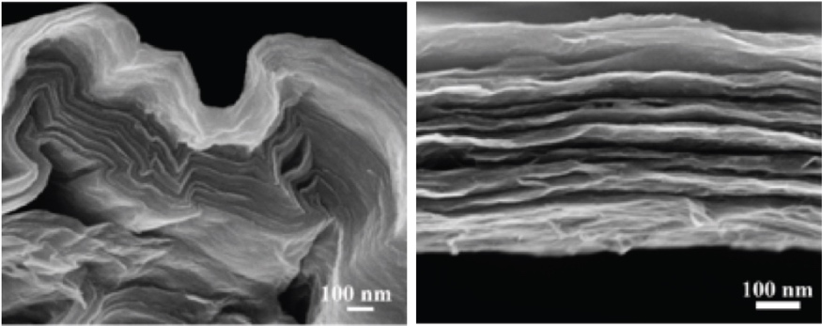
Fig. 1 SEM cross section of stacked GO layers used for supercapacitors. Left: spray coated layers. Right: blade coated layers.

I will show recent results on highly efficient all-carbon solid-state supercapacitors based on graphene and graphene oxide, achieving capacitance of more than 400 F/g (Zhao, Liu et al. 2017), putting into relation the capacitance with the physical characteristics of the structure, through a detailed evaluation of the accessible surface area. I will also review some of the achievements in this area obtained by using MOF structures in the electrodes (Zhao, Liu et al. 2018).

References

Horn, M., B. Gupta, J. MacLeod, J. Liu and N. Motta (2019). "Graphene-based supercapacitor electrodes: addressing challenges in mechanisms and materials." Current Opinion in Green and Sustainable Chemistry. 17, 42-48
Zhao, Y., J. Liu, M. Horn, N. Motta, M. Hu and Y. Li (2018). "Recent advancements in metal organic framework based electrodes for supercapacitors." Science China Materials 61(2): 159-184.
Zhao, Y., J. Liu, B. Wang, J. Sha, Y. Li, D. Zheng, M. Amjadipour, J. MacLeod and N. Motta (2017). "Supercapacitor Electrodes with Remarkable Specific Capacitance Converted from Hybrid Graphene Oxide/NaCl/Urea Films." ACS Applied Materials & Interfaces 9(27), 22588-22596

