Nanoscale optical bio-sensing and imaging with diamond quantum probes

David Simpson^{A}

^{A}School of Physics, University of Melbourne, Parkville, Victoria, 3010, Australia.

The nitrogen vacancy (NV) centre in diamond¹ has emerged as a promising system for nanoscale sensing and imaging due to its size and sensitivity to a range of physiological parameters including temperature², magnetic³ and electric fields⁴. The optical and quantum properties of the NV centre in diamond are ideal for biological imaging, the material itself is bio-compatible, the NV fluorescence is photo-stable and the quantum properties of the NV centre can be manipulated and readout at room temperature. These attributes have driven application of these quantum probes into biological systems^{5, 6}. The diamond quantum probes can be found in nanodiamonds <100 nm in size or engineered into 2D NV imaging arrays using single crystal diamond.

Here, I will describe our recent work exploiting 2D NV imaging arrays for magnetic imaging applications. In particular, I will show how these imaging arrays in diamond can be used to non-invasively map the magnetic properties of iron-oxide complexes in biological systems at the sub-cellular scale^{7, 8}, see Fig. 1. In addition, I will show how photonic architectures can be used to enhance the sensitivity of the diamond sensing arrays⁹ and discuss the future possibilities of this technology and how it can be applied to address significant and outstanding questions in biology.

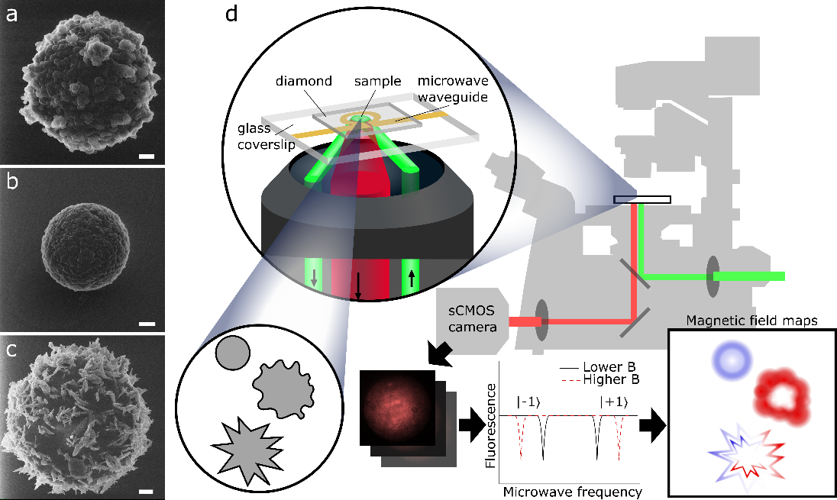
Fig. 1. Quantum-based magnetic microscope. The sample is deposited on a diamond sensor chip containing a layer of NV centres. The NV centres are optically excited by a green (532 nm) laser focused onto the sensor through the microscope objective; microwave excitation for the quantum control of the NV centre is delivered via a gold resonator situated below the diamond sensing chip. The NV fluorescence is filtered and imaged on an sCMOS camera. Fluorescence images are collected and analysed at various microwave frequencies to construct magnetic field maps.

References
1. M. W. Doherty, et al., Physics Reports 528 (1), 1-45 (2013).
2. A. Jarmola, et al., Phys. Rev. Lett. 108 (19), 197601 (2012).
3. G. Balasubramanian, et al., Nature 455 (7213), 648-651 (2008).
4. F. Dolde, et al., Nat. Phys. 7 (6), 459-463 (2011).
5. L. P. McGuinness, et al., Nat. Nanotech. 6 (6), 358-363 (2011).
6. D. A. Simpson, et al., ACS Nano 11 (12), 12077-12086 (2017).
7. J. M. McCoey, et al., arXiv:1902.09637 [physics.bio-ph] (2019).
8. J. M. McCoey, et al., Small 15 (18), 1805159 (2019).
9. D. J. McCloskey, et al., arXiv:1902.02464 [physics.optics] (2019).

