**Preparation and characterisation of hydrogel biointerfaces**

*Jenny MalmströmA,B, Badri Narayanan NarasimhanA,B, Matthew TingA,B*

ADepartment of Chemical and Materials Engineering, University of Auckland, Auckland, New Zealand; BThe MacDiarmid Institute for Advanced Materials and Nanotechnology, Wellington, New Zealand.

The success of stem cell therapies and tissue engineering relies on fundamental knowledge of cell fate and stem cell behaviour both in vivo and in vitro. Cells sense and adapt to forces and physical constraints imposed by the extra cellular matrix. Such mechanotransduction plays a crucial role in cell function, differentiation and cancer. The ECM mechanical rigidity and distribution of ligands are both sensed and modulated through the contractile and adhesive molecular machinery in the cells. This machinery consists of bonds between the ECM and transmembrane integrin receptors, adaptor protein and the force generating actomyosin cytoskeleton, often referred to as a molecular clutch.1

Previous technological developments have provided interfaces with well-defined patterns, chemistry or stiffness, which revolutionized how biological questions can be answered. Current research is expanding these parameters to exploring viscoelastic and strain stiffening materials, dynamic materials and controlled display/delivery of multiple signals.

In our research group, we are developing materials to achieve spatiotemporal control over mechanical properties, and materials aimed at controlled delivery of growth factors to study the synergies between mechanotransduction and growth factor signalling.

Specifically, we are tailoring the mechanical properties of hydrogels by polymerizing a second network inside polyacrylamide gels. The results highlight the importance of interactions between the two networks, where interacting networks give rise to a higher dissipation. By using light to polymerise the second network, it is possible to create gradients in dissipation, without changing the elastic modulus. We have also developed a range of conductive hydrogels, with the aim to provide tools for both electrical and mechanical stimulation of cells. The preparation and characterisation (mechanical and electrochemical) of these gels will be presented.

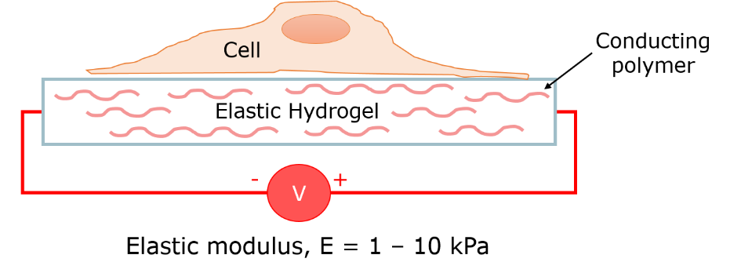

**Figure**: Illustration of conductive hydrogel biointerface.

**References**

1. A. I. Monteiro, T. Kollmetz and J. Malmström, Biointerphases **13** (6) (2018).