Multiplexed intermediate states saturation nanoscopy by Fourier spectral fusion

^{A}Chaohao Chen, ^{A}Baolei Liu, ^{A}Jiayan Liao, ^{A}Fan Wang, ^{A}Dayong Jin
^{A}Institute for Biomedical Materials and Devices (IBMD), Faculty of Science, University of Technology Sydney, NSW 2007, Australia.
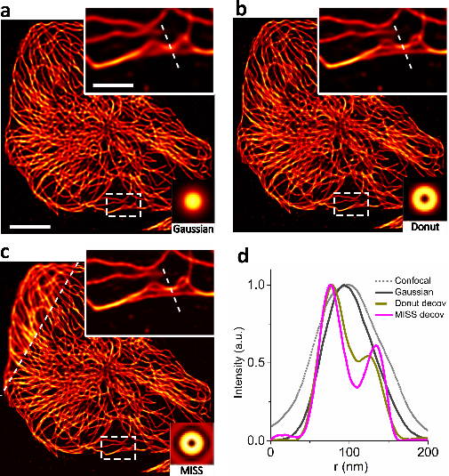
Figure. Simulated imaging of the MISS method to biological application. a Image by Gaussian PSF. b Image by Donut PSF. c Image by MISS fusion PSF. d Cross line profiles in a, b and c.

Introduction.
Optical microscopy is a technique suitable for biological investigation because it enables visualization analysis inside specimens with advantageous features such as non-contact and low damage. Classical optical microscopy is limited lateral resolution to 200 nm due to the Abbe’s diffract limitation¹.
Aims.
We present an alternate strategy called multiplexed intermediate states saturation (MISS) nanoscopy by the combination of point-scanning structured illumination and nonlinear photon response with digital Fourier fusion post-processing in spectral domain. Our approach encodes spatial information from the saturated fluorescent into the spectral channels and decodes it by extracting the maximum length of Fourier components for post digital efficient point spread function (PSF) engineering. By exploiting emission spectra and wavelength dependent of nonlinear photon response in upconversion nanoparticles (UCNP), we develop a multicolour Fourier spectral fusion algorithm to compensate specific frequency components deficiency caused by the focused doughnut beam, enlarging the optical system’s frequency shifting ability to reconstruct subdiffractional image.
Methods.
MISS nanoscopy uses the fact that a donut laser² focus is a special type of structured illumination carrying all the possible Fourier components allowed by the numerical aperture of an objective. Due to the multi-photon nonlinear saturation properties, the spectral dependence provides different PSFs for different colours to implement post processing super-resolution imaging. The maximum spatial information corresponding to the Fourier components are fused from each emission bands for post processing optical transfer function to reconstruct the super-resolved object. Finally, the image is reconstructed by summing up the different maximum contributions in Fourier domain using a reconstruction algorithm processes, as shown in Figure.
Results.
Applicable to UCNP–labelled structures of dense and complexity, MISS can obtain super-resolved image of COS-7 cell microtubules with λ/15 spatial resolution.
Discussion.
The main idea in MISS is that nonlinearity in the excitation of the fluorescence results in an equivalent excitation PSF with extended frequency content. As in nonlinear structured illumination, higher frequencies generated by nonlinear excitation can be used to measure spatial frequencies beyond diffraction limit.
Conclusion.
We add the spectral degree of freedom to superresolution microscopy by using PSF engineering, referring to the modification of the microscope’s PSF. The basic idea behind this technique is that superresolution can be achieved by maximizing the overall coverage of emission patterns in the Fourier domain³. We anticipate this work provides a simple and easy imaging technique for biological or material studies in the future.
References
1. Hoover, E. E. & Squier, J. A. Advances in multiphoton microscopy technology. Nat. Photonics 7, 93–101 (2013).
2. Chen, C. et al. Multi-photon near-infrared emission saturation nanoscopy using upconversion nanoparticles. Nat. Commun. 3290 (2018).
3. Urban, B. E. et al. Super-resolution two-photon microscopy via scanning patterned illumination. Phys. Rev. E 91, 042703 (2015).

