Nano-imaging of functional nanomaterials by spatially resolved X-ray diffraction

Steven J. Leake^{A}, M.-I. Richard^{A,B}, J. Carnis^{A,B}, Tao Zhou^{A}, S. Fernandez^{A}, V. Favre-Nicolin^{A}, P. Boesecke^{A}, Olivier Thomas^{B}, Tobias U. Schülli^{A}
^{A}ID01/ESRF, The European Synchrotron, CS 40220, F-38043 Grenoble Cedex 9, France.; ^{B}Aix Marseille Université, CNRS, Université de Toulon, IM2NP UMR 7334, 13397, Marseille, France.

We present spatially resolving X-ray diffraction based tools than are of relevance for most emerging nanomaterials. There resolving power has proven to reach down to length scales relevant for catalysis and basic solid state chemistry as encountered in most electrochemical systems. While developments over the recent years were mainly affected by the rather slow evolution of basic X-ray equipment like optics and detectors, their level of maturity now leads to a limit set by the X-ray source itself. With worldwide efforts in the upgrading or new conception of synchrotron sources, improvements of several orders of magnitude in the throughput of these methods are expected in the next years. Our first results show the relevance of such new tools in complex experimental environments as encountered in nanotechnology and chemistry.

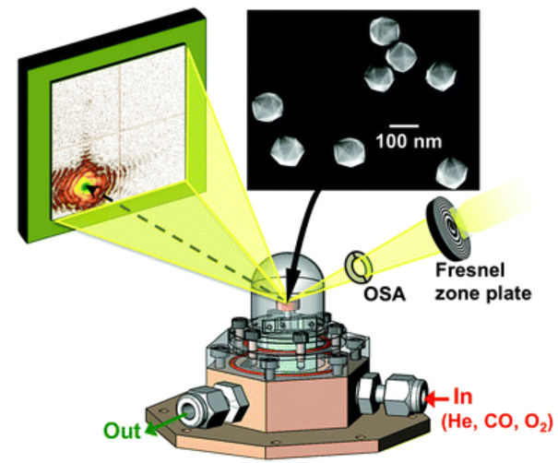
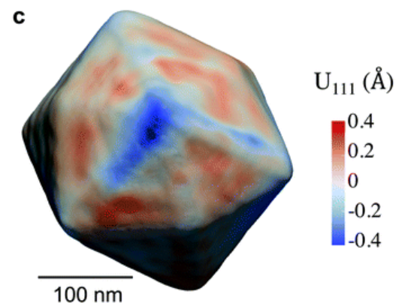
Although many basic principles and processes in what is in a wider sense called nanotechnology are known and exploited since more than a century, their development and improvement is still very much based on a trial and error approach. In the sector of energy materials such as batteries or electrochemical systems for energy conversion, the physiochemical complexity has prevented over decades a clear-cut understanding of processes and reactions at the nanoscale, essentially due to the absence of suited characterization tools. Looking at the example of batteries, and the worldwide implication of research groups on only a few prominent material systems, it becomes clear that rarely any progress in a technology depended so much on characterization and understanding of the complete reaction system. On the other hand, many common characterization techniques cannot assess such electrochemical systems under reaction but rather their constituents once isolated or extracted from the reactive system. Lab and synchrotron based powder X-ray diffraction has been a tool of choice for investigating nanomaterials in complex systems and under reaction. But only very recent developments permit to overcome the absence of spatial resolution of this method. We have developed several diffraction based microscopes that have proven their usefulness in microelectronic samples where high strain resolution needs to be combined with large fields of view and sub micrometer resolution[1-3]. For typical nanostructures as present in catalytic reactions or batteries, coherent X-ray diffraction imaging tools will allow to zoom into single nanocrystallites with the potential of 3D nanometric imaging. While most published examples of the recent past aimed at high spatial resolution in static samples, current efforts are aiming at the operando assessment at a time resolution of relevance in chemical engineering, while preserving a 3D spatial resolution well below 10 nm [1]. These tools that are today mainly limited to a small expert community are prone to quickly develop into one of the most powerful operando assessment methods; We will present the current state of the art of X-ray diffraction based microscopy with examples for imaging of individual nanostructures.
Fig. 1: Example for coherent X-ray diffraction and reconstruction of a catalytic nanoparticle during reaction (from ref. 3)

References
- S. J. Leake et al., (2017), Coherent nanoscale X-ray probe for crystal interrogation at ID01, ESRF–The European Synchrotron, Materials&Design, 119, 470-471.
- S. J. Leake & T. U. Schülli, (2018), X-ray nanobeam diffraction imaging of materials, Curr. Opin. Solid State Mater. Sci., 22, 188–201.
- S. Fernandez et al., (2019). In situ structural evolution of single particle model catalysts under ambient pressure reaction conditions. Nanoscale, 11,331-338.

