A Fully Recyclable Battery Cell Design for Substainable Environment
Prof. Shanqing Zhang
Centre for Clean Environment and Energy, School of Environment and Science, Gold Coast Campus, Griffith University, QLD 4222, Australia
Email: s.zhang@griffith.edu.au

Abstract:
Large-scale applications of rechargeable batteries consume nonrenewable resources and produce massive amounts of end-of-life wastes, which raise sustainability concerns in terms of manufacturing, environmental, and ecological costs. Therefore, the recyclability and sustainability of a battery should be considered at the design stage by using naturally abundant resources and recyclable battery technology. Herein, we design a fully recyclable rechargeable sodium ion battery with bipolar electrode structure using Na₃V₂(PO₄)₃ as an electrode material and aluminum foil as the shared current collector. The successful incorporation of sustainability into battery design suggests that closed-loop recycling and the reutilization of battery materials can be achieved in next-generation energy storage technologies.
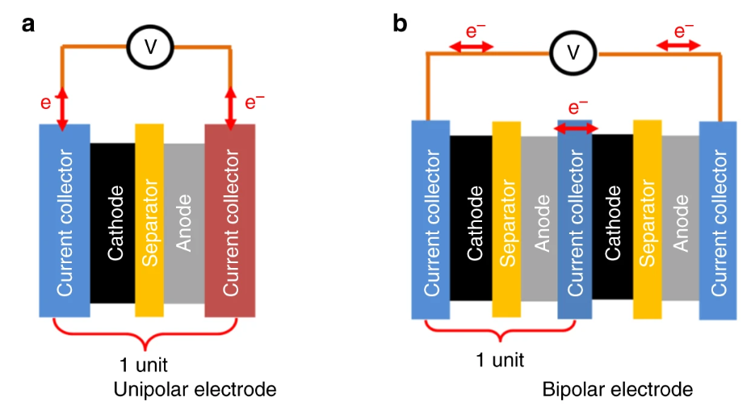

Figure1， Design of a recyclable cell structure. a Schematic of the conventional unipolar electrode structure (one-unit cell). b Schematic of the proposed bipolar electrode structure (two-unit cell).
References
- T Liu, Y Zhang, C Chen, Z Lin, S Zhang, J Lu, , Nature communications 2019, 10 (1), 1965

