Multiple ion binding in ionic solutions

Paolo Raiteri,^{A*} Natalya A. Garcia, ^{A} Marco De La Pierre,^{B} and Julian D. Gale^{A}

^{A} Curtin Institute of Computation and The Institute for Geoscience Research (TIGeR), Curtin University, Perth 6845, Australia
^{B} Pawsey Supercomputing Centre, Kensington 6151, Australia

In the last decade there has been growing evidence than stable pre-nucleation clusters are present in ionic solution and that they play a key role in the nucleation of minerals (Gebauer 2008, Gebauer 2018). However, most of the support for the existence of the thermodynamic stability of these species is indirectly inferred from experiments, which do not have the required resolution to directly observe the clusters in situ. Analogously, computational techniques lack the required processing power to study the thermodynamic stability of these species at realistic experimental conditions (Demichelis 2011, Stawski 2019).
Here I will present our recent computational work on the development of new forcefields for calcium carbonate and phosphate species in aqueous solution and their application to the study of the thermodynamic stability of pre-nucleation clusters. Our results, for different Ca-bearing ionic solutions, show that multiple ion associates are indeed (meta)-stable thermodynamic states, which is consistent with many experimental observations. I will also show how we can use computational methods to directly inform surface x-ray reflectivity experiments and obtain an accurate structure of the mineral-water interface with atomic resolution.

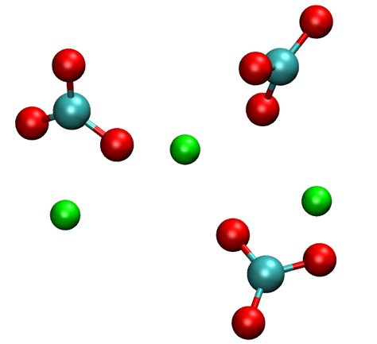

Fig. 1. Instantaneous configuration of a three formula unit CaCO₃ cluster as observed in our simulations.

References
R. Demichelis, P. Raiteri, J. D. Gale, D. Quigley, and D. Gebauer, “Stable Prenucleation Mineral Clusters Are Liquid-Like Ionic Polymers,” Nat. Commun., vol. 2, p. 590, 2011.
D. Gebauer, A. Voelkel, and H. Coelfen, “Stable Prenucleation Calcium Carbonate Clusters,” Science, vol. 322, no. 5909, pp. 1819–1822, 2008.
D. Gebauer, P. Raiteri, J. D. Gale, and H. Cölfen, “On classical and non-classical views on nucleation,” Am. J. Sci., vol. 318, no. 9, pp. 969–988, Nov. 2018.
T. M. Stawski, A. E. S. Van Driessche, R. Besselink, E. H. Byrne, P. Raiteri, J. D. Gale, and L. G. Benning, “The Structure of CaSO₄ Nanorods: The Precursor of Gypsum,” J. Phys. Chem. C, p. acs.jpcc.9b04268, Jun. 2019.

p.raiteri@curtin.edu.au

