Effect of various surface conditions on Van der Waals epitaxy of MoS₂

N. Zebardastan^{A}, Nunzio Motta^{A}, J. Bradford^{A}, Bharati Gupta^{A}, J. Lipton-Duffin^{A}, J. MacLeod^{A}, A Wolff^{A}, K. Hu^{B}, Y. Ito^{B}, C.Mariani^{C}, M.G.Betti^{C}

^{A} School of Chemistry, Physics and Mechanical Engineering and Institute for Future Environments, Queensland University of Technology, Brisbane 4001, QLD, Australia

^{B} Institute of Applied Physics, Graduate School of Pure and Applied Sciences, University of Tsukuba, Tsukuba 305-8573, Japan

^{C}Department of Physics, Sapienza University, 00185 Rome, Italy

Synthetic Van der Waals heterostructures of layered materials such as graphene, hexagonal boron nitride and transition metal dichalcogenides (TMDs) have attracted attention recently due to the ability to tune specific properties for essential electronic and optoelectronic applications [1]. Combination of 2D layers of graphene and semiconducting TMDs (such as MoS2) have previously been demonstrated to exhibit exceptional optoelectronic properties since graphene’s high carrier mobility and broad-spectrum absorption is complemented by high optical absorption of monolayer TMDs owing to their direct bandgap [2].
In this work we compare and discuss the characteristics of epitaxial MoS₂/graphene heterostructures grown on substrates with different structural properties such as small and large terrace size graphene/SiC (Figure 1a and b) as well as self-standing Nano Porous Graphene (NPG). Growth has been performed by Chemical Vapor Deposition by using Ar as carrier gas and MoO₃ and S precursors. A systematic investigation of the resulting heterostructures has been conducted by microscopy and spectroscopy as a function of the growth temperature and precursor fluxes. The morphology and size of MoS₂ layers has a very different evolution on diverse substrates: the size of graphene/SiC terraces effects the size and uniformity of 2D TMD layers, while on NPG, MoS₂ forms a 2D wetting layer on graphene which evolves into rhombohedral crystals for large precursor fluxes or longer deposition times (Figure 1c).

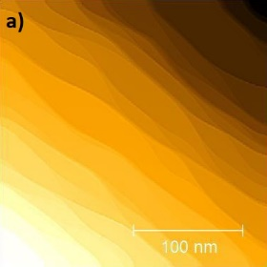 | 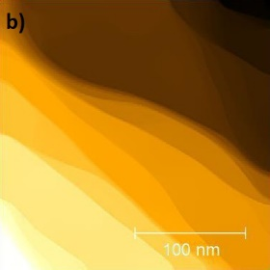 | 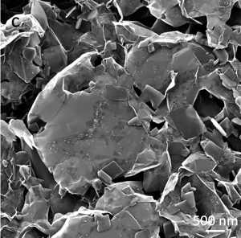
Figure 1: Scanning Tunneling Microscopy images of graphene/SiC with a)small terraces and b) large terraces. c) Helium Ion Microscopy image of MoS₂ grown on Nanoporous graphene.

References:
Jin, C, et al., (2018). Ultrafast dynamics in van der Waals heterostructures. Nature Nanotechnology, 13(11), 994-1003.
Zhang, W, et al., (2014). Ultrahigh-Gain Photodetectors Based on Atomically Thin Graphene-MoS2 Heterostructures. Scientific Reports, 4, 3826.

