**Measurements of sub-nanometric shifts in lattice parameters due to residual stress in self-piercing riveting (SPR) joint**

*Rezwanul HaqueA, Ayodele OlofinjanaA , Anna ParadowskaB and Yvonne DurandetC*

ASchool of Science and Engineering, University of the Sunshine Coast, Australia; BAustralian Nuclear Science and Technology Organisation, Australia; CFaculty of Science, Engineering and Technology, Swinburne University of Technology, Australia.

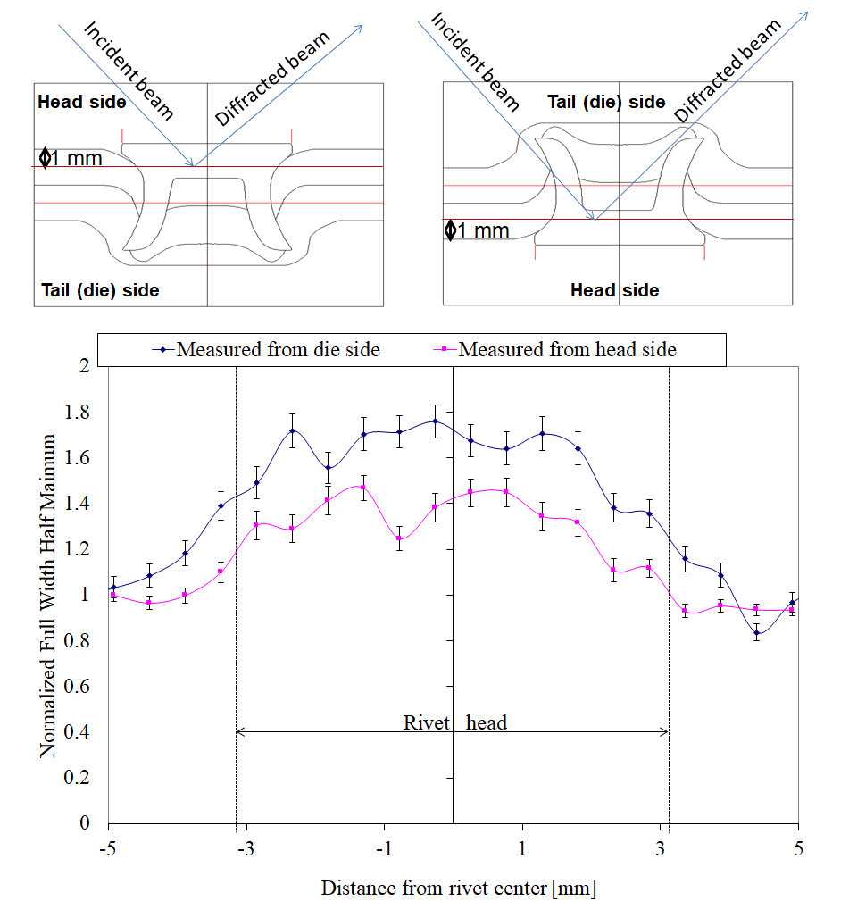**Introduction**: Self-Piercing Riveting (SPR)is a high speed mechanical fastening technique and is now being used in the automobile industries due to its ability to join a diverse range of materials. However, the plastic deformation involved in the process is attended by residual stress (Haque et al., 2012) that is in a magnitude of ${10}^{3}$ (Khezri et al., 2001). To optimize the SPR process it is necessary to understand the relationship of the magnitude of residual stress with the scale of sub-nanometer size shifts in lattice parameters.

**Aims**: This study is aimed at exploring the use of Strain scanner ‘Kowari’ at the Australian Nuclear Science and technology organisation in measuring residual stress-induced shifts in crystalline lattice parameters. The measuring procedures need to be optimised with Neutron beam diffraction to enable differentiation of signals for processing of diffraction peak.

**Methods**: In order to establish the optimum instrument configuration, strains were measured at 30 locations in a riveted joint both from head side and tail side as shown in Fig. 1. acquisition time was varied from 240 s up to 1500 s depending on the measurement location and direction.

Figure 1 Effect of measuring sides FWHM of the neutron peak

**Results/Discussion**: Peak broadening were observed in three orthogonal directions. The normalized value of FWHM reached 1.4 and 1.8 for the head side and die side measurements respectively. In both cases, peak broadening occurred for the measurement points situated in rivet head. This is due to the different microstructure of the sheet and rivet material. For the optimum instrument condition. The measured lattice spacing in rivet was 1.168713 ± 0.000459 Å and in sheet material was 1.168713 ± 0.000459 Å.

**Conclusion**: This optimum instrument condition can be used for the future measurement of residual strain/stress in SPR joints.

**References**

Haque et al., (2012). Feasibility of measuring residual stress profile in different self-pierce riveted joints, Science & Technology of Welding & Joining, 17 (2012) 60-68.

Khezri et al., (2001). Simulation of self piercing riveting of the DP600 sheet steel in thickness 1+2 and 2+2 mm and of DP800 in thickness 1+1mm, , in, Swedish Institute for Metals Research, IM-2001-537, 2001

**Acknowledgment**

The authors acknowledge AINSE for awarding grant No. 6646 to carry out neutron diffraction studies at ANSTO.

Corresponding author: rhaque@usc.edu.au