**Homogeneous integration of carbon nanotubes in thermoplastics**

**towards pressure-sensitive therapeutic insoles**

*Myra Ruth PobleteA, Juan Pablo Escobedo-DiazB, Jaqueline BousieC, Sean O’ByrneB, Heiko TimmersA*

ASchool of Science, UNSW Canberra, ACT, Australia;

BSchool of Engineering and Information Technology, UNSW Canberra, ACT, Australia;

CFaculty of Health, University of Canberra, ACT, Australia

**Introduction**

The integration of conductive carbon nanotubes into an insulating matrix may provide material phases that can convert physiological parameters to piezoresistive signals. An important application is in-shoe pressure sensing to help diabetes patients manage their condition [1-2]. Piezoresistive sensing may be best because of its relative simplicity, low cost, durability, and mass-producibility.

Towards this goal, this research aims to create nanocomposites by embedding multi-walled carbon nanotubes (MWCNT) in thermoplastics commonly used in therapeutic insoles, namely polyurethane (TPU) and ethylene vinyl acetate (EVA). MWCNTs have a higher surface-area-to-volume-ratio than e.g. carbon black. Under compression conductive networks may thus form readily even at low concentrations. TPU and EVA are advantageous matrices for the nanotubes, since they can be made over a wide range of hardness, thicknesses, densities, and mechanical properties which makes them particularly suitable for orthotic insoles[3-4]. Optimal performance of the composite piezoresistive material requires a homogenous distribution of nanotubes. Initial work has thus focused on embedding MWCNT into TPU and characterising homogeneity and ohmic resistance.

**Methods and Results**

The nanocomposites were fabricated by diluting a MWCNT masterbatch (Plasticyl TPU1001) with pure TPU (Estane 54610) using a G-100T Morgan Industries ram injection moulder. The resulting composite strands were cut into small pieces and fed again into the moulder for up to three times.

****A homogenous phase has not yet been achieved as indicated by the presence of lighter spots attributed to pure TPU (arrows). SEM was found to not distinguish regions of different nanotube density. The inhomogeneity is corroborated by the ohmic resistance that was consistently above the measurement limit of the Agilent multimeter. In order to function as a sensing material, a measurable electrical resistance is required, so that a piezoresistive response may be interpreted.

Figure 1. Typical sample (a), optical micrograph after initial moulding (b), after three passes (c) with depleted regions indicated. SEM does not identify inhomogeneities (d,e).

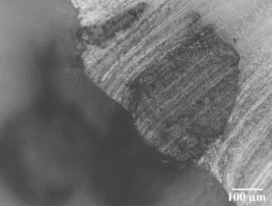

b

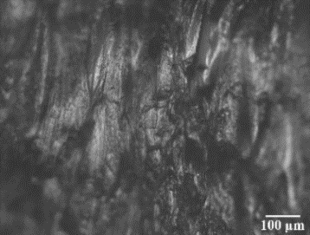

c

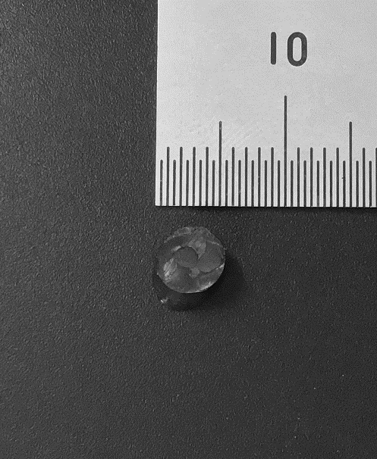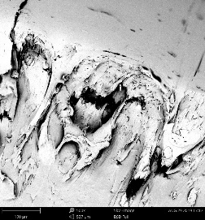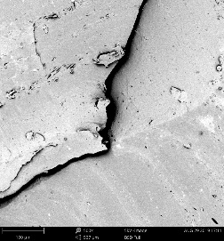

a

d

e

**Summary and Outlook**

MWCNT have successfully been integrated in TPU with the aim of creating a composite material suitable for pressure-sensing therapeutic insoles. Resistance measurements and microscopy suggest that the homogeneity achieved is as yet insufficient for piezoresistive characterisation under cyclic compression loading (Fig. 2). Future work will attempt to improve homogeneity by using a screw extruder prior to injection moulding.

Figure 2. Piezoresistivity test under cyclic compression loading

**References**

[1] J. Heikenfeld *et al.*, “Wearable sensors:…,” *Lab Chip*, vol. 18, no. 2, pp. 217–248, 2018.

[2] X. Yin, *et al.*, “A flexible high-sensitivity …,” *J. Mater. Chem. C*, vol. 3, no. 35, pp. 9247–9252, 2015.

[3] A. C. Fauli, *et al.*, “Physical evaluat...,” *J. Am. Podiatr. Med. Assoc.*, vol. 98, no. 3, pp. 229–238, 2008.

[4] W. T. Lo, *et al.*, “New methods for …,” *J. Rehabil. Res. Dev.*, vol. 51, no. 2, pp. 311–324, 2014.