Photoactive surfaces for infection control

Sheeana Gangadoo¹, Vi Khanh Truong¹, Enrico Della Gaspera¹, James Chapman^{1,*}

¹School of Science, College of Science, Engineering and Health, RMIT University, Melbourne, VIC 3001, Australia;
* james.chapman@rmit.edu.au

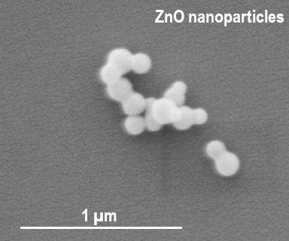
Methicillin-resistant Staphylococcus aureus (MRSA) is a leading cause of infection world-wide [1] where common antibiotics are now failing to deliver kill properties to these bacteria. New approaches to killing MRSA have been developed in the form of metal and metal oxide nanoparticles [2]. These new approaches have proven effective in reducing the number of MRSA colonies by producing kill mechanisms such as the production of reactive oxygen species [3]. In this study, confocal laser scanning microscopy (CLSM), microscopy (SEM, TEM and AFM) and plate counts were used to confirm the antibacterial efficacy of zinc oxide nanoparticles (5 nm) and at low concentrations of 0.5 % (w/v) demonstrating an effective kill capacity of 80% in the colonies tested. The ZnO nanoparticles will also be developed as photoactive surface coatings which are representative of some commonly used surfaces in medical and environmental settings, furthermore, the regeneration and subsequent kill capacity will be examined.

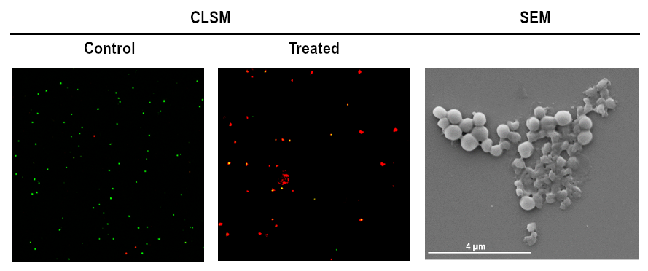
Figure 2. CLSM showing viability of MRSA cells predominating in control (green) samples and inactivated MRSA cells predominating in the ZnO nanoparticles-treated samples (red). Inactivated MRSA cells can be seen in the SEM image (on the right).

References
- Lee, A. S. de Lencastre, H. Garau, J. Kluytmans, J. Malhotra-Kumar, S. Peschel, A. & Harbath, S. (2018). Methicillin-resistant Staphylococcus aureus. Nat. Rev. Dis. Primers, 4, 18033.
- Gold, K. Slay, B. Knackstedt, M. & Gaharwar, A. K. (2018). Antimicrobial activity of Metal and Metal-Oxide Based Nanoparticles. Adv. Ther. 1, 3, 1700033.
- Kadiyala, U. Turali-Emre, E. S. Bahng, J. H. Kotov, N. & VanEpps, J. S. (2018). Unexpected insights into antibacterial activity of zinc oxide nanoparticles against methicillin resistant Staphylococcus aureus (MRSA). Nanoscale. 10, 10, 4927-4939.

