Hybrid nanodiamond materials: the present and future

Brant C. Gibson
ARC Centre of Excellence for Nanoscale BioPhotonics, School of Science, RMIT University,
Melbourne, VIC 3001, Australia;

Light-based imaging and sensing tools can assist with our understanding of the complex chemical and molecular processes taking place in and around cells in the living body [1]. Fluorescent nanodiamonds (NDs) are an attractive nanoscale-tool that have a range of unique properties which make them highly desirable for a range of applications including bioimaging and biosensing applications [2]. Their fluorescence is produced via optical excitation of atomic defects, such as the negatively charged nitrogen vacancy centre, within the diamond crystal lattice. Possessing long-wavelength emission, high brightness, no photobleaching, no photoblinking, nanometer size, a room temperature sensitivity to magnetic and microwave fields, and an exceptional resistance to chemical degradation make NDs almost the ideal fluorescent bioimaging nanoprobe [3].

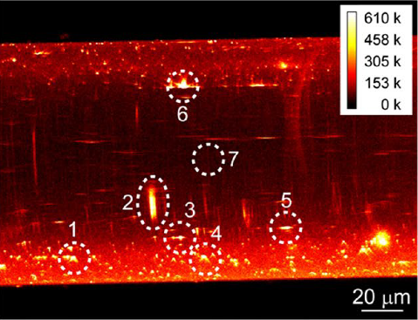
I will discuss these exciting properties in detail and give some examples of the effect of surface functionality on their fluorescent properties [4], their use as fluorescent probes for pH [5] and hydrogen peroxide sensing in biological systems [6], and the effect of particle size on nanodiamond fluorescence and colloidal properties in biological media [7]. In addition, I will also discuss hybrid biosensing applications including the incorporation of NDs into polycaprolactone [8] and silk. Furthermore, I will also examine some future directions of hybrid nanodiamond materials including optical fibres that are intrinsically sensitive to magnetic fields [9], which contrast with conventional telecommunication-grade fibres.
Figure 1. Confocal fluorescence map from the side of a diamond-doped tellurite glass optical fibre [9].

References
[1] P. Reineck and B. C. Gibson, ‘Near-infrared fluorescent nanomaterials for bioimaging and sensing’, Advanced Optical Materials, (2016).
[2] D. Ho, Nanodiamonds - Applications in Biology and Nanoscale Medicine, Springer US, (2010).
[3] L. P. McGuinness, Y. Yan, A. Stacey, D. A. Simpson, L. T. Hall, D. Maclaurin, S. Prawer, P. Mulvaney, J. Wrachtrup, F. Caruso, R. E. Scholten & L. C. L. Hollenberg, ‘Quantum measurement and orientation tracking of fluorescent nanodiamonds inside living cells’, Nature Nanotechnology, 6, pp. 358–363 (2011)
[4] P. Reineck, D. M.W. Lau, E. Wilson, C. Deeleepojananan, V. N. Mochalin, B. C. Gibson, ‘The effect of surface functionality on the fluorescence of detonation nanodiamonds’, ACS Nano, 11 (11), (2017).
[5] P. Reineck, D. Lau, E. R. Wilson, N. Nunn, O. Shenderova, and B. Gibson, ‘Visible to near-IR fluorescence from single-digit detonation nanodiamonds: excitation wavelength and pH dependence’, Sci. Rep. 8, Article number: 2478 (2018).
[6] M. S. Purdey, P. K. Capon, B. J. Pullen, P. Reineck, N. Schwarz, P. J. Psaltis, S. J. Nicholls, B. C. Gibson, A. D. Abell, ‘An organic fluorophore-nanodiamond hybrid sensor for photostable imaging and orthogonal, on-demand biosensing’, Sci. Rep. 7, Article number: 15967 (2017).
[7] E. R. Wilson, L. M. Parker, A. Orth, N. Nunn, M. Torelli, O. Shenderova, B. C. Gibson and P. Reineck, ‘The effect of particle size on nanodiamond fluorescence and colloidal properties in biological media’, Nanotechnology, Vol 30, 38, (2019).
[8] K. Fox, T. A. Phong, D. W. M. Lau, T. Ohshima, A. D. Greentree, and B. C. Gibson, ‘Nanodiamond-polycaprolatone composite: A new material for tissue engineering with subdermal imaging capabilities’, Materials Letters, 185, 185–188 (2016)
[9] Y. Ruan, D. A. Simpson, J. Jeske, H. Ebendorff-Heidepriem, D. W. M. Lau, H. Ji, B. C. Johnson, T. Ohshima, S. Afshar V., L. Hollenberg, A. D. Greentree, T. M. Monro & B. C. Gibson, ‘Magnetically sensitive nanodiamond-doped tellurite glass fibers’, Sci. Rep. 8, Article number: 1268 (2018).

