Porous poly(2-hydroxyethyl methacrylate) (PHEMA) hydrogels doped with silver nanoparticles — one-step synthesis, characterisation, antibacterial efficacy and biocompatibility.

Praveen,^{A} Shinko Suzuki,^{B} Matt Myers,^{A,D} Peta L. Clode,^{E} Traian V. Chirila,^{B,C} Christine F. Carson,^{F} Murray V. Baker^{A,B}

^{A}School of Molecular Sciences, The University of Western Australia, Perth, Australia. ^{B}Queensland Eye Institute, Brisbane, Australia. ^{C}AIBN and Faculties of Health Science and Engineering, University of Queensland, Brisbane, Australia. ^{D}CSIRO Energy, Kensington, WA, Australia. ^{E}CMCA, The University of Western Australia, Perth, Australia. ^{F}School of Biomedical Sciences, The University of Western Australia, Perth, Australia.

Introduction: 2-Hydroxyethyl methacrylate (HEMA) can be polymerized either thermally (Dziubla et al. 2016) or photochemically (Li and Lee, 2005) via free-radical methods to give poly(2-hydroxyethyl methacrylate) (PHEMA). When HEMA is polymerized from aqueous solution, macroporous PHEMA sponges can be obtained (Baker et al. 2009).

Aims
(a) To synthesize porous PHEMA sponges doped with Ag nanoparticles (Ag NP-PHEMA) in one step. (b) To assess the morphology, biocompatibility and antibacterial activity of Ag NP-PHEMA materials.

Methods
A quartz vial was charged with a solution of HEMA, ethylene glycol dimethacrylate, and AgNO₃, in water. The vial was sealed (septum) and 2,2-dimethoxy-2-phenylacetophenone (photoinitiator) in ethanol was added. Polymerization of HEMA and reduction of Ag⁺ was induced by irradiation at 350 nm. Polymer morphology and Ag nanoparticles in the resulting Ag NP-PHEMA materials were characterised by SEM and TEM (Fig. 1). Anti-bacterial properties of Ag NP-PHEMA were assessed by agar disk diffusion experiments.
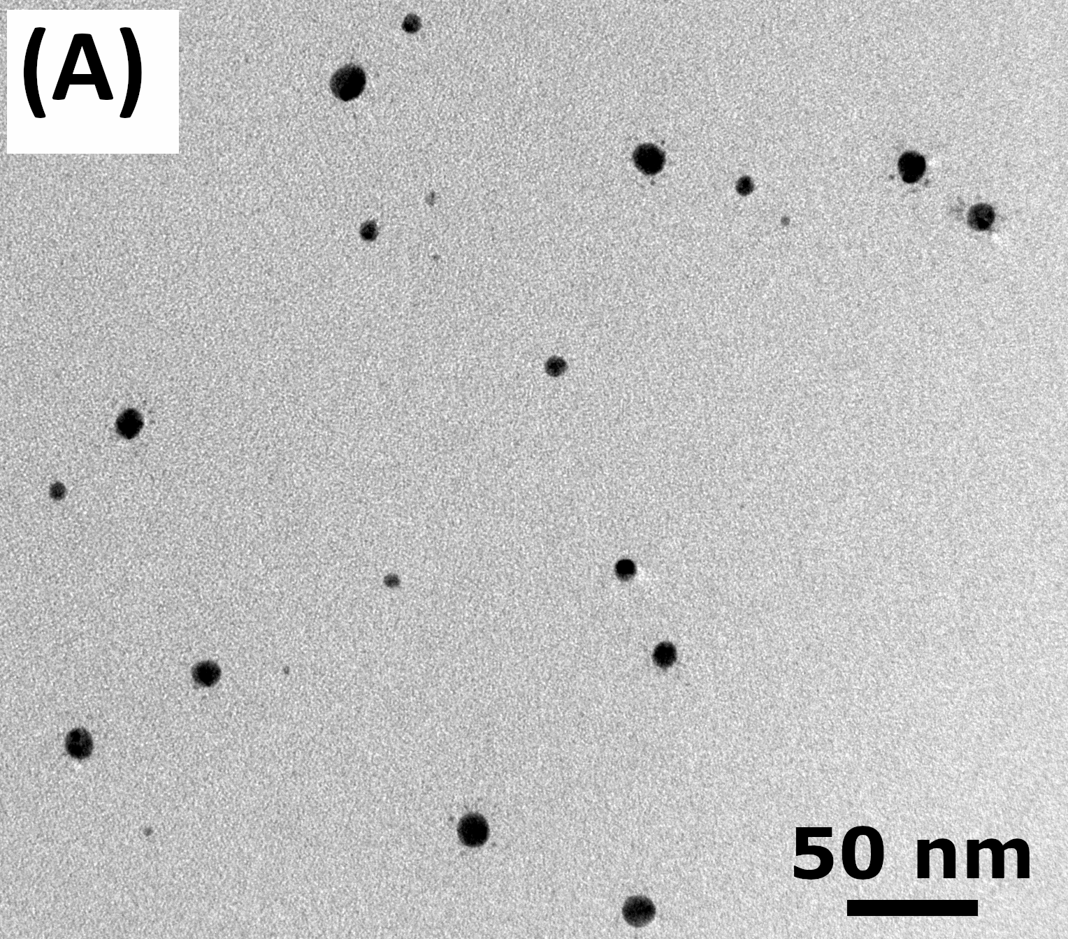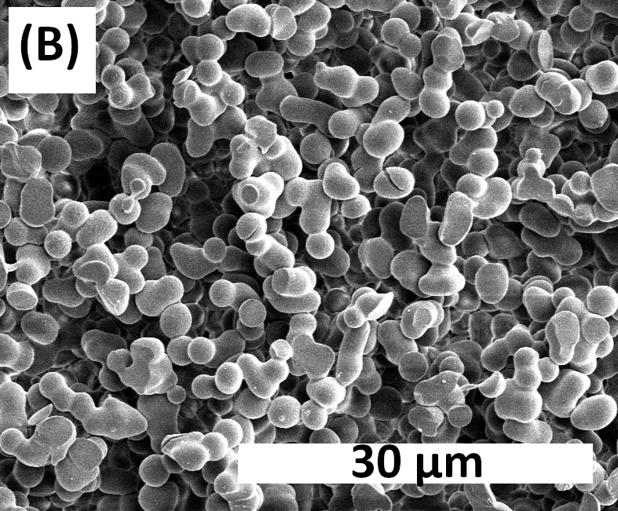

Fig. 1. (A) Bright field TEM image of Ag NP-PHEMA. (B) SEM image of Ag NP- PHEMA.
Results
Ag NP-PHEMA hydrogels exhibited polymer droplet morphology with interconnected pores of dimensions on the micron scale. Ag nanoparticles were spherical in shape with diameters of 2 to 20 nm, and were distributed evenly throughout the polymer matrix. The Ag NP-PHEMA hydrogels were effective against both E. coli and S. aureus bacteria.

Conclusion
Porous, biocompatible Ag NP-PHEMA hydrogels possessing antibacterial properties can be synthesized in a simple one-step process.

References
- Baker M.V., Brown D.H., Casadio Y.S., and Chirila T.V. (2009). The preparation of poly(2-hydroxyethyl methacrylate) and poly{(2-hydroxyethyl methacrylate)-co-[poly(ethylene glycol) methyl ether methacrylate]} by photo-initiated polymerisation-induced phase separation in water. 50, 5918-27.
- Dziubla T.D., Torjman M.C., Joseph J.I., Murphy-Tatum M., and Lowman A.M. (2016). Evaluation of porous networks of poly(2-hydroxyethyl methacrylate) as interfacial drug delivery devices. Biomaterials, 22, 2893-9.
- Li L. and Lee L.J. (2005). Photopolymerization of HEMA/DEGDMA hydrogels in solution. 46, 11540-7.

murray.baker@uwa.edu.au

