Opto-mechanical characterisation of hybrid biomimetic networks

Jan Lauko^{A}, Petri Turunen^{A}, Zhao Wang^{A}, Amanda W Kijas^{A}, Alan E Rowan^{A}
^{A}Australian Institute for Bioengineering and Nanotechnology, The University of Queensland, Brisbane, Australia.

Reconstituted networks of natural extracellular matrices (ECMs), such as collagen or fibrin show a large increase in stiffness upon externally applied stress or deformation.¹
Recently, a new type of biomimetic hydrogel, based on oligo(ethylene glycol)-grafted polyisocyanopeptide (PIC), was developed in our group.² Remarkably, the PIC polymer gelates upon warming at concentrations as low as 0.005 %-wt polymer, with material properties almost identical to those of intermediate filaments and natural ECMs.^{2,3} The application of these materials in cell growth and drug therapeutics revealed the importance of polymer non-linear mechanics.³
Here we present the synthesis and opto–mechanical studies of novel PIC- and biopolymer-based hybrid networks. By implementing confocal–rheology (Fig. 1)⁴ as the main tool for the characterization of the network structure and topology, we gain insights on how the 3D architecture and mechanics relate to one another. We will present the instrument’s fine measurement capabilities and applications, where the influence of mechanical force applied on the material by the rheometer component can be concurrently visualized by the confocal microscope. We believe that this setup provides us with new means of studying natural and synthetic ECM materials, understanding the processes associated with mechanotransduction in biological model systems and as an end goal to understand in more detail the interface of ECM and cells.
Approaches on how to control the hybrid hydrogel properties, their detailed micro-rheological studies, and demonstration of the power confocal–rheology in studies of both synthetic and biological systems will be shown.
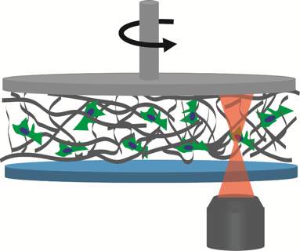
Figure 1. Schematics of a confocal–rheology experiment, where a soft polymer (in this case containing cells) is visualized by fluorescence microscope while simultaneously applying strain to the sample by the rheometer plate on top.

References
- P.A. Janmey, et al. PLoS ONE, 2009, 4, e6382; E. S. Place, et al. Nat. Mater. 2009, 8, 457; C. Storm, et al. Nature, 2005, 435, 191.
- P. H. J. Kouwer, M. Koepf, et al. Nature, 2013, 493, 651; M. Jaspers, et al. Nat. Commun. 2014, 5, 5808; M. Jaspers, et al. Adv. Funct. Mater. 2015, 25, 6503; D.C. Schoenmakers, et al. Nat. Commun. 2018, 9, 2172.
- R. K. Das, et al. Nature Materials 2016, 15, 318.; R. Hammink, et al. ACS Omega, 2017, 2, 937; S. M. Bruekers, et al. Cell Adh. Migr. 2016, 10, 495; P. de Almeida, et al. Nat. Commun. 2019, 10, 609.
- T. Sentjabrskaja, et al. Sci. Rep. 2015, 5, 11884; S. K. Dutta, et al. Rev. Sci. Instrum. 2013, 84, 063702.

