Hydrogel platform with independently tailorable mechanical properties for directing stem cell fate

Diwei Ho^{A}, Peter K.H. Lee^{A,B}, Ian L. Chin^{C}, Yu Suk Choi^{C}, Adam D. Martin^{D}, Pall Thordarson^{E,F}, Marck Norret^{A}, K. Swaminathan Iyer^{A}

^{A}School of Molecular Sciences, The University of Western Australia, Perth, WA, Australia; ^{B}Department of Biology & Biochemistry, University of Bath, Bath, BA2 7AY, United Kingdom; ^{C}School of Human Sciences, The University of Western Australia, Perth, WA, Australia; ^{D}Department of Biomedical Sciences, Macquarie University, Sydney, NSW, Australia; ^{E}School of Chemistry, University of New South Wales, Sydney, NSW, Australia; ^{F}The Australian Centre for Nanomedicine and the ARC Centre of Excellence in Convergent Bio-Nano Science and Technology, Sydney, NSW, Australia.

Abstract
Stem cells are undifferentiated cells that have the capacity to differentiate into various cell types with widespread applications in regenerative medicine and tissue engineering. Stem cell behaviour and fate has been known to be influenced by their microenvironmental biochemical and biophysical cues (Chen et al. 2019). Hydrogels are commonly utilised in the regulation and study of stem cell fate due to their similarities to extracellular matrix that stem cells are typically exposed to (Tsou et al. 2016). However, the mechanical properties (i.e. shear modulus, Young’s modulus and porosity) of hydrogels used in stem cell fate studies are frequently coupled together; changing one property will affect another. This aspect makes it difficult to control and limit the variables when studying stem cell fate. In this work, we develop and characterise a library of hydrogels made from dendronized polymers of which the mechanical properties and characteristics (Fig. 1) can be adjusted independently from one another. This is achieved through the crosslinking of flexible dendritic polymers (pHEMA-ran-GMA) with varying poly(amido amine) (PAMAM) dendron generations (G₃ to G₅) and GMA substitution on the polymer backbone. The mechanically tuneable hydrogel platform reflects the mechanical properties of various biological tissues and can be a useful tool in the investigation of stem cell fate.
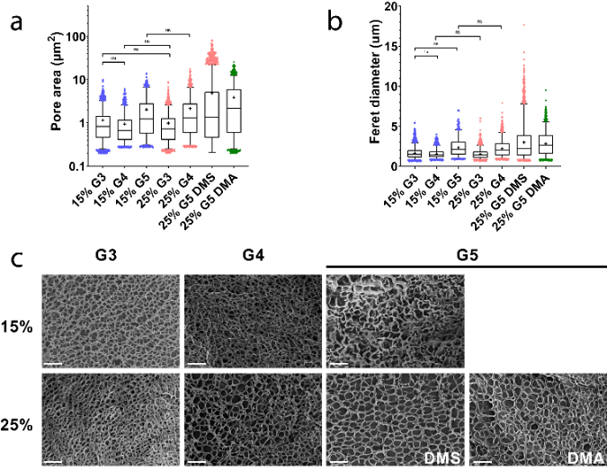

Fig. 1. Porosity of hydrogels made from pHEMA-ran-GMA dendritic polymers with varying PAMAM dendron generations (G₃ to G₅) and GMA substitution on the polymer backbone. Pore areas (a) and Feret diameters (b) were determined through analysis of SEM images (c) of freeze-dried hydrogels. (a&b) Data represented as box plots with mean shown as ‘+’ and median is drawn as a line across the box. Lower and upper bars represent the 5- and 95-percentile of all data points, respectively. (c) Scale bars = 10 µm.

References
- Chen, L., Huang, T., Qiao, Y., Jiang, F., Lan, J., Zhou, Y., Yang, C., Yan, S., Luo, K., Su, L. & Li, J. (2019). Perspective into the regulation of cell-generated forces toward stem cell migration and differentiation. J. Cell. Biochem. 120, 8884-8890.
- Tsou, Y-H., Khoneisser, J., Huang, P-C. & Xu, X. (2016). Hydrogel as a bioactive material to regulate stem cell fate. Bioact. Mater. 1, 39-55

