**MEMS-based strain engineering for epitaxial grown semiconductive nanowires**

*Yoshitada IsonoA*

ADepartment of Mechanical Engineering, Graduate school of Engineering, Kobe University, Kobe, Japan.

Introduction.

One-dimensional semiconductive nanowires are attractive functional nanomaterials to MEMS because of specific physical properties attributable to their nanometric size and low structural dimensions. For example, the fracture strength of silicon nanowires (SiNWs) drastically increases with a reduction of their sample size [1], which is because of a decrease of latent defect in the sample. Also, SiNWs are expected to be used as highly sensitive piezoresistors for mechanical force sensors [2]. This is because semiconductive nanowires show a drastic change in the electronic structural features such as their band gap and effective mass under enormous mechanical strain, which can be used to determine the electron mobility [3]. Quantitative evaluation of the mechano-electric properties of individual semiconductive nanowires under straining is significant for their application to high-sensitivity MEMS sensors. This report introduces the experimental technique to evaluate mechanical, electrical, and optical properties under uniaxial straining of epitaxial grown semiconductive nanowires using *E*lectrostatically *A*ctuated *N*anotensile *T*esting devices (*EANAT*) developed by authors, and its experimental results.

Methodology.

The basic structure of the *EANAT* includes four functional parts: the specimen, electrostatically driven actuator, differential capacitive displacement sensor, and calibration parts, as shown in Fig. 1.

Results and Discussions.

Not only mechanical but also mechano-electrical properties (i.e., piezoresistivity) have so far been evaluated for several nanowires, such as SiNWs, SiCNWs [4], and MWCNTs. The optical property of GaPNWs was also studied by the collaborators. As an example, Fig. 2 shows variations of the resistance change ratio with an increase of the uniaxial tensile strain for the 3C-SiCNW with the SiOx shell and for the 3C-SiCNW without the shell. The maximum gauge factors were –31.8 at 0.005 ε in the SiCNW coated with SiOx shell; however, it decreased to –13.2 at 0.02 ε and –7.0 at 0.03 ε. In contrast, the gauge factor of the SiCNW without the shell was –13.6 at 0.01 ε, and it decreased to –11.5 at 0.026 ε. These variations of the gauge factor could have been dominated by the strain induced modulation of the surface potential at a low strain level, and the strain induced band feature change at a high strain level.

Conclusion.

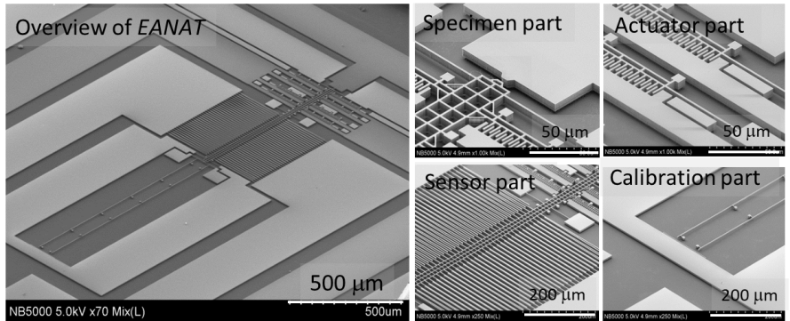Semiconductor nanowires become one of the key functional elements of MEMS. Also, semiconductive nanowires with excellent physical properties are required for further miniaturization and higher sensitivity of MEMS sensors. The research into strain engineering of semiconductive nanowires is becoming increasingly important.



Fig. 2 Piezoresistivity of 3C-SiCNWs

Fig. 1 SEM images of EANAT

**References**

1. Namazu, T., Isono, Y. &Tanaka, T. (2000). Evaluation of Size Effect on Mechanical Properties of Single Crystal Silicon by Nano-Scale Bending Test using AFM, J. MEMS., 9,450-459.
2. He. R. & Yang, P. (2006). Giant piezoresistance effect in silicon nanowires, Nature Nanotech., 1, 42-46.
3. Nakamura, K., et al. (2008). First-Principles Study on Piezoresistance Effect in Silicon Nanowires, Jpn. J. Appl. Phys. 47, 5132-5138.
4. Nakata, S. et al. (2019). Strain engineering of core–shell silicon carbide nanowires for mechanical and piezoresistive characterizations, Nanotech., 30, 265702 (12pp).