Near-infrared Absorbing Acceptor Improves the Nanophase Segregation of Ternary Organic Photovoltaic Blend with a Performance of 12%

Chih-Ping Chen ^{A} * Chun-Kai Wang ^{B}, Bing-Huang Jiang,^{c}, Ru-Jong Jeng^{c} and Ken-Tsung Wong^{b}
^{A} Department of Materials Engineering, Ming Chi University of Technology, New Taipei City 243, Taiwan. E-mail: cpchen@mail.mcut.edu.tw
^{b} Department of Chemistry, National Taiwan University, Taipei 10617, Taiwan.
^{c} Institute of Polymer Science and Engineering, National Taiwan University, Taipei 10617, Taiwan.
Introduction.
Non-fullerene acceptors (NFAs) with advantages of low open circuit voltage (Voc) loss, tunable energy levels and absorptions in visible and near-infrared (NIR) region are promising for high efficiency organic photovoltaics (OPVs). ^{[1]}
Figure 1. Structure of the material.
Aims.
The NFA was designed as a NIR-absorbing acceptor to study the blend film morphology of ternary OPV. The NFA was aimed to provide the complementary light harvesting and tailored the nanophase morphology for ternary OPV.
Methods.
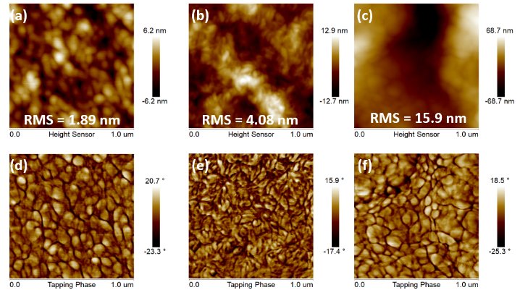
We design and synthesis an A-D-A-configured molecule PTTtID-Cl (Figure 1). The strong ICT character enables the resulting material to have strong absorption in the range of 700–850 nm in CHCl₃ solution, and red-shifted absorption centered at 881 nm was observed in thin film. We paired the low band-gap polymer PM7 and IT-4F, with PTTtID-Cl to explore their BHJ nanophase segregation and optoelectronic properties of ternary OPV.^{[2]}
Figure 2. (a) J-V characteristics, (b) IPCE spectra of ternary devices
Results & Discussion.
An optimized power conversion efficiency (PCE) of 12.0% (AM 1.5 G 100mW/cm²) was obtained with PM7:IT-4F:PTTtID-Cl ratio at 1:0.15:0.85 w/w. The 72% and 23% PCE improvement compared to PM7:PTTtID-Cl- and PM7:IT-4F-based binary device, respectively, are mainly caused by increased J_{sc} and FF values (Figure 2). The higher J_{sc} values of the device with ratio optimization than PM7:IT-4F-based binary device mainly resulted from superior photocurrents in the region of 750-900 nm shown in IPCE spectrum, which indicates the benefit of introducing NIR-absorbing PTTtID-Cl. Figure 3 reveals the topology and phase images of binary and ternary blends. The rough surface morphology (RMS=15.9nm) and severe aggregation in Figure 3f imply the severe D/A segregation existing only in PM7:PTTtID-Cl blend. The severe D/A segregation might lead to low probability for exciton dissociation at D/A interfaces and high trap-assisted recombination in active layers, leading to lower low Jsc and Voc values for PM7:PTTtID-Cl-based devices, respectively. The smaller nanoscale phase segregation was observed for the PM7:PTTtID-Cl:IT-4F (1:0.15:0.85. w/w) ternary blend which exhibits the highest PCE compared with PM7:PTTtID-Cl and PM7:IT-4F binary blends.
Figure 3. Topology and phase images of PM7:IT-4F:PTTtID-Cl ratio at (a, d) 1:0:1, (b, e) 1:0.15:0.85 and (c, f) 1:1:0.
Conclusion.
The ternary OPV device with the best ratio of PM7:PTTtID-Cl:IT-4F = 1:0.15:0.85 (w/w) achieves a J_{sc} of 19.6 mA cm^{–2}, a V_{oc} of 0.87 V, and a FF of 70.2% and a PCE of 12.0%. The optimized ratio of PM7:PTTtID-Cl:IT-4F = 1:0.15:0.85 (w/w) exhibits appropriate BHJ morphology with nanophase separation, expanded absorption region and lower dark currents which could contribute to higher values of J_{sc}, FF and thus higher PCEs.
References
[1] C.-K. Wang, B.-H. Jiang, Y.-W. Su, R.-J. Jeng, Y.-J. Wang, C.-P. Chen, K.-T. Wong, ACS Applied Materials & Interfaces 2019, 11, 1125-1134.
[2] C.-P. Chen, Y.-C. Li, Y.-Y. Tsai, Y.-W. Lu, Solar Energy Materials and Solar Cells 2018, 183, 120-128.

