Effects of microstructure and growth conditions on quantum emitters in gallium nitride

Minh A Nguyen^{A*}, Tongtong Zhu ^{B} Mehran Kianinia^{A}, Fabien Massabuau^{B}, Igor Aharonovich^{A}, Milos Toth^{A}, Rachel Oliver^{B}, Carlo Bradac^{A}
^{A}School of Mathematical and Physical Sciences, University of Technology Sydney, Ultimo, Australia
^{B}Department of Material Science and Metallurgy, University of Cambridge, Cambridge, United Kingdom

Introduction and Aims
Single-photon emitters (SPEs) hosted in solid-state materials are a fundamental component to various quantum-based technologies – combining the outstanding optical properties of atoms with the convenience and scalability of solid-state hosts. Gallium nitride is one such material, hosting optically stable room-temperature emitters across from the UV to infrared range and having well-established growth and nanofabrication techniques^{1,2}. The origin of their emission however is unknown, thus we perform this study to explore how growth conditions and thus, microstructure of GaN matrices affect spatial and optical characteristics of SPEs³.

Methods & Materials
Synthesis of the GaN samples were performed using varying methods of metal-organic vapour phase epitaxy on substrates of sapphire and silicon. Optical characterisation was performed on a lab-built confocal microscope with 532 nm CW excitation, with measurements including spectra and second order autocorrelation measurements. Atomic force and cathodoluminescence microscopy (AFM and CL) analysis were used for spatial characterisation of the emitters.

Results & Discussion
Eight GaN samples were grown and tailored to explore how different growth parameters would have on the formation of hosted quantum emitters–that is; dislocation density, growth substrate, growth orientation, and doping of extrinsic impurities. PL characterisation reveals a wide range of ZPL energies spanning 560 – 750 nm, from samples with; low and high dislocation density, Fe-doped, and semi-polar growth direction. A typical spectra is shown in Fig. 1a along with its corresponding second-order autocorrelation function confirming its SPE nature (Fig. 1b). Spatial characterisation involved the correlation between surface-terminating threading dislocations from AFM and emitter positions in PL and CL within a well-defined region of interest (Fig. 1c). Although there is no observable correlation between dislocation and emitter positions, there is a correlation between emitter density and dislocation density–hinting at the potential role of intrinsic impurities or point defects as the SPE origin.
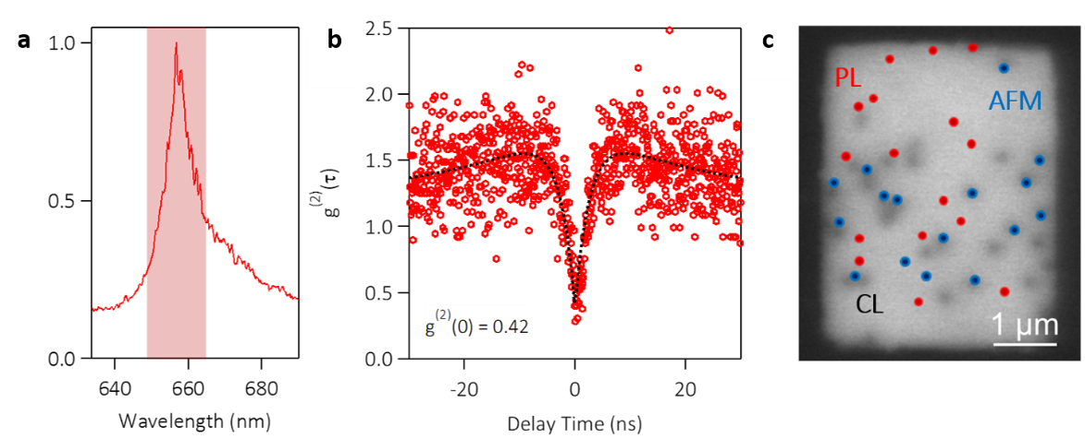
Figure 1. a) Typical spectra of GaN SPEs with b) its corresponding second-order autocorrelation function. c) Overlay of panchromatic CL (black), PL (red), and AFM (blue) emitter positions.
References
- Berhane, A.M.; et. al. Adv. Mater. 2017, 29(12), 1605092
- Denis, A.; Goglio, G.; et. al. Mater. Sci. Eng., 2006, 50, 167-194
- Nguyen, M.; Xu, T.; et. al. APL Mater. 2019, 7, 081106
*Minh.A.Nguyen@student.uts.edu.au

