Enhanced treatment of glioblastoma using EphA2-targeted bispecific antibodies an adjuvant for a doxorubicin-loaded hyperbranched polymer
Phillip W. Janowicz^{1,2,3}, Zachary H. Houston^{1,2,3}, Nicholas L. Fletcher^{1,2,3}, Craig Bell^{1,2,3}, Kristofer Thurecht^{1,2,3,4}
¹The Centre for Advanced Imaging (CAI), The University of Queensland, Brisbane, QLD 4072, Australia
²Australian Institute for Bioengineering and Nanotechnology (AIBN), The University of Queensland, Australia
³Australian Research Council Centre for Excellence in Convergent Bio-Nano Science and Technology (CBNS)
⁴Australian Research Council Centre for Innovation in Biomedical Imaging Technology (CIBIT)

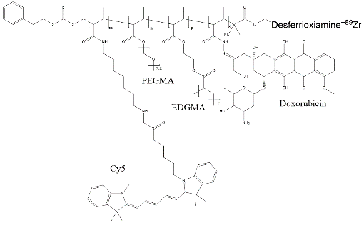
Glioblastoma is a devastating cerebral tumour for which the median survival time is 10-12 months. Current treatment involves surgical resection of the tumour, followed by chemotherapy and/or radiotherapy. Recent work in our laboratory has characterised the accumulation and retention of nanomedicines within brain tumours, following progressive leakiness of the blood brain barrier (BBB). A major challenge is to not only deliver high amounts of these nanomedicines into the tumour, but also into the extremities of the complex heterogeneous environment. This work further evaluated the delivery of doxorubicin-loaded PEG-based hyperbranched polymers into murine glioma at an optimal time-window. The polymers were synthesised using established RAFT-based strategies and targeted to Ephrin receptors unregulated on the tumours using a bispecific antibody approach previously reported by our group. A treatment regime of five equal biweekly doses was then tested, and the effect of treatment was monitored in real time using MRI and PET scanning. Overall, this research provides insight into the advantages of using hyperbranched polymers, and EphA2-targeting with bispecific antibodies, for intracellular-localised and safer chemotherapy of glioblastoma.
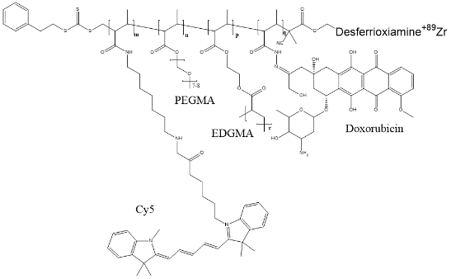
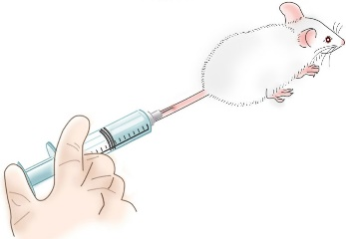
A

B
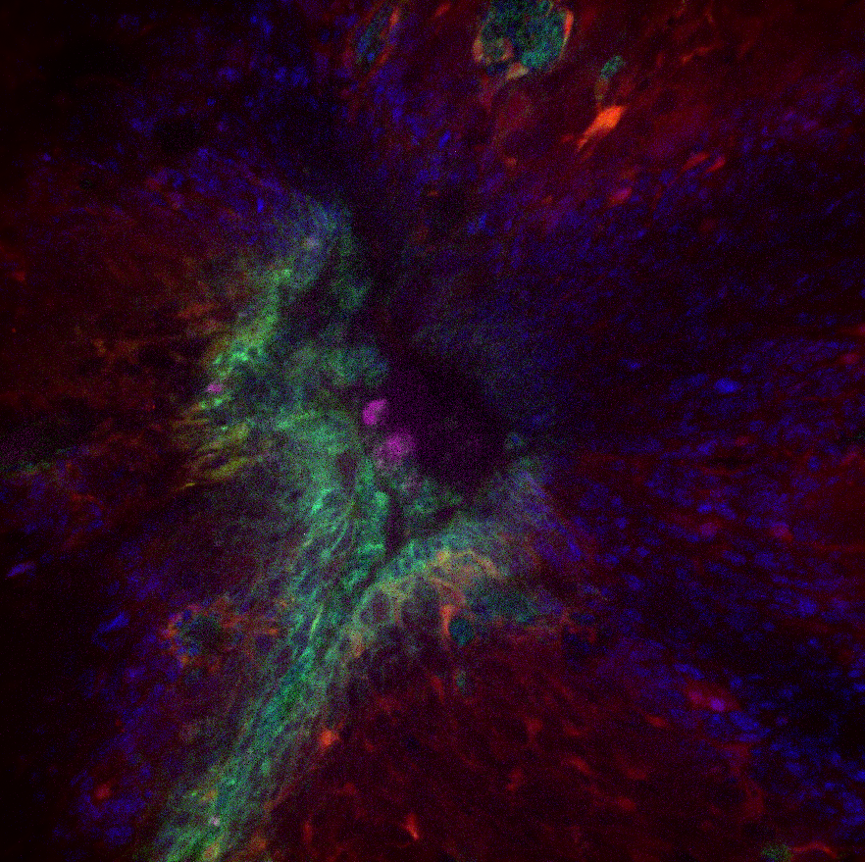
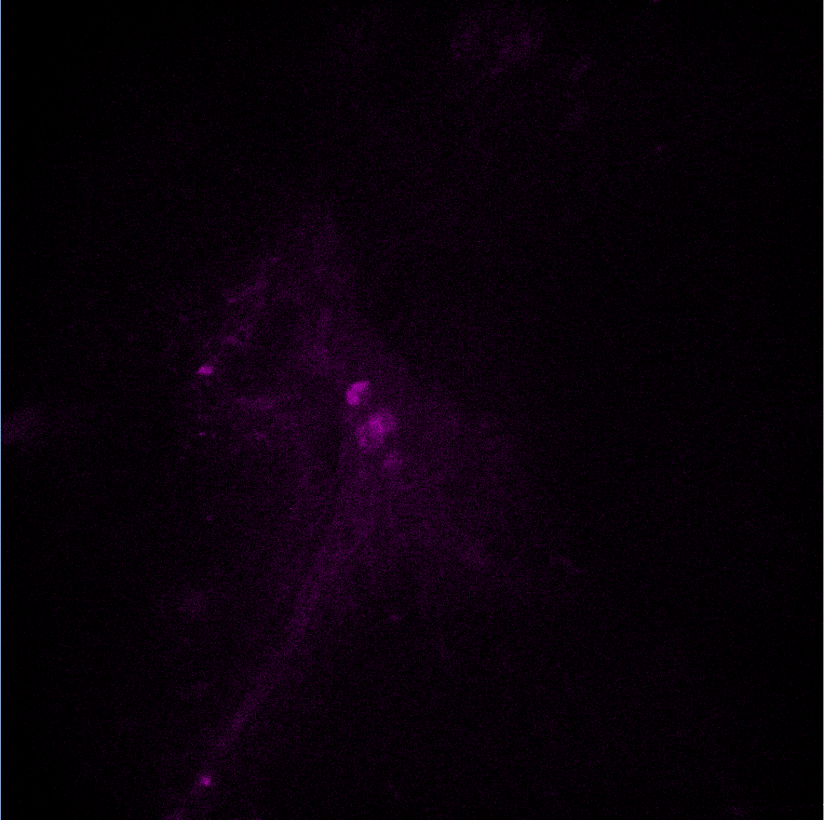
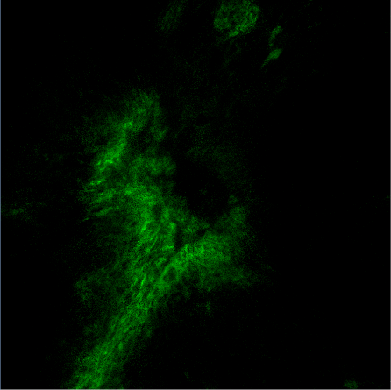
Merge
Doxorubicin

Polymer

Figure 1. A) Structure of the hyperbranched polymer, which is injected intravenously into a new glioma mouse model. B) Spinning disk confocal images showing release of doxorubicin (green) and hyperbranched polymer (Cy5, magenta) into astrocyte-dense tumour area (GFAP, red; DAPI, blue). Scale bar represents 100 µm.
__________________________________________________________________________________
Phillip Janowicz
Title: PhD Student
Affiliation, Country: Centre for Advanced Imaging, Australia
Phone: +61439381111
Personal History:
2015-2018 Götz Laboratory, Clem Jones Centre for Ageing Dementia Research
Since 2019 Thurecht Laboratory, Centre for Advanced Imaging
Research interests: Brain drug delivery, in vivo imaging, microscopy

