Development of high-throughput in vitro tumour models with microfabrication technologies

Guocheng Fang^{A}, Hongxu Lu^{A}*, Gungun Lin^{A} and Dayong Jin^{A}*

^{A} Institute for Biomedical Materials and Devices, Faculty of Science, The University of Technology Sydney, Ultimo, New South Wales 2007, Australia.

Multicellular tumour spheroids become a simple and effective 3D in vitro model for drug screening, which mimics the complexity of tumour in vivo^{1,2}. Size of spheroids is one of the most concerned parameters, which relates to the drug penetration, cellular metabolism, angiogenesis³. Current methods can only either generate uniform-sized spheroid at once or hardly control the size. Here, we report a liquid-dome method in which the liquid spatial distribution is modulated, which therefore could simultaneously produce the gradient-sized spheroids on a single chip. Using human breast adenocarcinoma MCF-7 cells for the concept validation, we showed the hemisphere-shaped dome and square-shaped dome reached to ~3.4 and ~12.8 folds area size modulation ability, respectively. We also profiled the size-dependent spheroid behaviours such as growth rate, drug penetration, co-culture phenotype. This method breaks the boundaries that the microwells can only generate the uniformed-size spheroids at once. We believe this simple and cost-effective method offers a useful tool for the drug screening and in vitro tumour modelling.
In addition, we used a droplet-based microfluidic technology to generate high-throughput tumour models, including tumour spheroids, organoids and mouse breast tumour chunks. The droplets had a uniform spherical shape. The cells/tissues were embedded in various hydrogels as supporting matrices and showed high viability during the culture. These tumour models can be used for the screening of nanomedicine products.

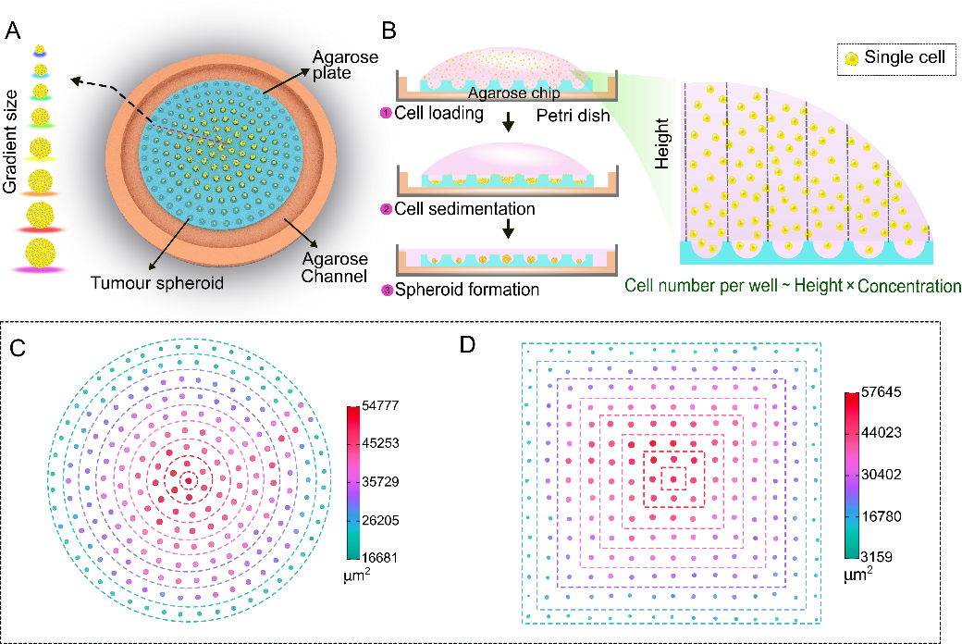

Figure 1. Schematic mechanism of the gradient-sized tumour spheroid formation (a) Design of the chip, (b) formation mechanism, (c) size distribution on the round-array chip, (d) size distribution on the square-array chip.

References
1. J. Friedrich, C. Seidel, R. Ebner and L. A. Kunz-Schughart, Nat. Protoc., 2009, 4, 309–324.
2. Y. Li and E. Kumacheva, Sci. Adv., 2018, 4, 1–11.
3. J. P. Ward and J. R. King, Math. Biosci., 2003, 181, 177–207.

