Metal contacts on meso-porous silicon for MEMS based thermo-resistive sensors

Pritam Sharma^{A}, Xiao Sun^{A}, John Dell^{A}, Gia Parish^{A,} Adrian Keating^{A}
^{A}School of Engineering, University of Western Australia, Crawley, Australia;

Introduction
Present day materials used for thermo-resistive MEMS sensing have fabrication incompatibilities and low performance limitations. Porous Silicon (PS) being compatible with standard CMOS processing can overcome these limitations [1]. However, obtaining low resistivity metal contact on PS for MEMS resistive sensing is a challenge mainly due to the high defect densities at the PS surface and PS/Si interface [2]. To achieve this, one way is to passivate the PS films [2] and anneal the metal contacts. Passivation will prevent the films from oxidizing in ambient conditions and annealing will decrease the contact resistance. In this work, PS films were passivated by thermal nitridation [3] and different deposited metal contacts (Al, Cr/Au and Ti) were annealed at various temperatures. The current-voltage (I-V) characteristics were measured to determine the optimum metal contact for nano-manufacturing of high sensitivity MEMS based PS thermo-resistive sensors.

Methods
PS films were fabricated with 80% porosity and 2.5 µm thickness using anodization in 15% HF/ethanol electrolyte. The films were passivated by rapid thermal annealing in N₂ at 600 °C [3]. Concentric circular metal contacts with inner radius 1 mm and 10 µm gap were deposited. Al and Cr/Au were deposited using thermal evaporation whereas Ti was deposited using E-beam evaporation. I-V curves were obtained by lateral measurement between concentric metal contacts using a HP 4156A semiconductor parameter analyser.

Results
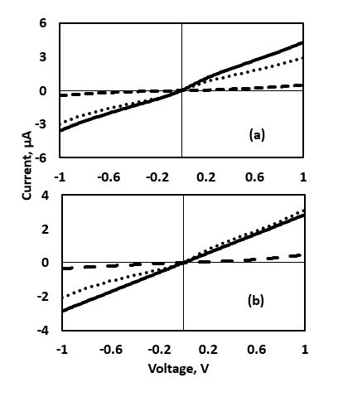
Fig. 1a shows the I-V results after annealing Al/PS contacts at various temperatures. Al forms a eutectic with Si at 570°C. However, we observed that at 450°C the current decreased significantly due to the delamination of the Al film from the PS surface. The maximum annealing temperature, which resulted in no delamination and maximum current, was at 300°C. Similar results were obtained for Cr/Au contacts annealed at 450°C. However, Ti contacts on PS could be annealed up to 600°C without any delamination, which we believe is due to the higher eutectic temperature with Si. The I-V results for Ti/PS contacts are shown in Fig 1b. The contact resistance between Ti/PS annealed at 600°C is reduced compared with Al/PS and Cr/Au/PS annealed at 300°C. Further, the I-V characteristic became linear over the measured range, indicating good ohmic contacts. Tolerating an annealing temperature of 600°C for metal contacts is important for MEMS based PS thermo-resistive sensors. For PS films on Si substrate, the current path is vertically through the PS/Si interface and laterally through the Si substrate. Electropolishing [4] in HF releases the films from Si, allowing the primary current path to be laterally through the PS and subsequently enabling high sensitivity MEMS-based resistive sensors to be fabricated. However, this removes the surface passivation layer, leads to atmospheric oxidation, and makes it necessary to re-nitridise the films at 600°C. Therefore, it is essential that the metal contacts have the ability to withstand temperatures up to 600°C for these applications. This indicates Ti is the most promising metal for making contacts in thermo-resistive based PS-MEMS applications.
Fig. 1. (a) Al/PS annealed at different temperatures (dotted: No annealing, line: annealed at 300°C, dash: annealed at 450°C). (b) Al, Cr/Au and Ti contacts annealed at different temperature. (dotted : Al annealed at 300°C, dash: Cr/Au annealed at 300°C, line: Ti annealed at 600°C).

References
1. Sharma, P., et al (2018) COMMAD :( 31-34).
2. Canham, L., et al (2014) Handbook of Porous Silicon.
3. James, T. D., et al (2011) Electrochemical and Solid-State Letters, 13(12).
4. Sun, X., et al (2017) Journal of Micromechanics and Microengineering 27(4).
Email : pritam.sharma@research.uwa.edu.au

