Making Light Work of Adaptive Micro- and Nanomaterial Design
Christopher Barner-Kowollik
¹ School of Chemistry, Physics and Mechanical Engineering, Institute for Future Environments, Queensland University of Technology (QUT), 2 George St, Brisbane, QLD 4000, Australia.
² Macromolecular Architectures, Institut für Technische Chemie und Polymerchemie, Karlsruhe Institute of Technology (KIT), Engesserstrasse 18, 76131 Karlsruhe, Germany

Light-driven molecular surgery at precise locations within complex macromolecules as well as on three dimensional direct laser written micro- and nano-constructs in the mildest possible fashion (visible light) and without any catalyst becomes possible with efficient light driven, λ-orthogonal, quantitative ligation protocols. Advanced light-induced processes enable the parallel encoding of multiple (bioactive) molecules onto predefined locations on 3D microstructures in one step as well as the wavelength dependent addressing of specific parts of molecules for their highly orthogonal functionalization (λ-orthogonal photochemistry). The lecture will highlight how macromolecular synthetic processes can be directed in their selectivity by different colours of light and, critically, how different colours of light can be used to control chemical reactivity and even completely hold thermal reaction channels. Such colour guided reaction manifolds can be exploited as orthogonal triggers artificial enzyme design, the fabrication of single cell scaffolds, the synthesis of sequence defined information coded macromolecules and diffraction unlimited laser lithography, enabling nano 3D printing.
Critically, the lecture will introduce a new material class, i.e. Light Stabilized Dynamic (LSD) materials, which are stabilized in a photonic field and be disassembled by the mildest trigger of all: Darkness.

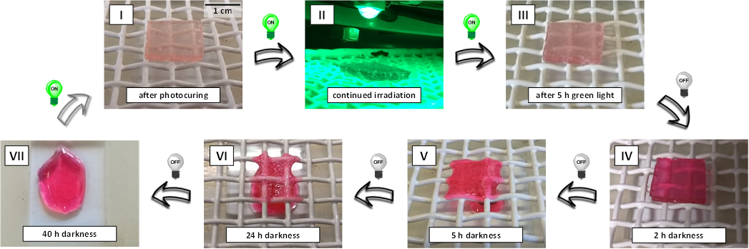

¹Houck, H. A.; Blasco, E.; Du Prez, F. E.; Barner-Kowollik, C. J. Am. Chem. Soc. 2019, doi.org/10.1021/jacs.9b05092; ²Feist, F.; Menzel, J. P.; Weil, T.; Blinco, J. P.; Barner-Kowollik, C. J. Am. Chem. Soc. 2018, 140, 11848-11854; ³Frisch, H:, Menzel. J. P.; Bloesser, F. R.; Marschner, D.; Mundsinger, K.; Barner-Kowollik, C. J. Am. Chem. Soc. 2018, 140, 9551−9557; ⁴Menzel, J. P.; Noble, B. B.; Lauer, A.; Coote, M. L.; Blinco, J. P.; Barner-Kowollik, C. J. Am. Chem. Soc. 2017, 139, 15812-15820; ⁵Houck, H. A.; Du Prez, F. E; Barner-Kowollik, C. Nat. Comm. 2017, 8, 1869.

