Peptide-driven binding, exfoliation, and stabilization of 2D nanosheet materials

Atul D. Parab^{A}, Akin Budi^{B}, Nermina Brljak^{A}, Joseph M. Slocik^{C}, Rahul Rao^{C}, Rajesh R. Naik^{C}, Tiffany R. Walsh^{B}, Marc R. Knecht^{A,D}
^{A}Department of Chemistry, University of Miami, Coral Gables, Florida, USA; ^{B}Institute for Frontier Materials, Deakin University, Geelong, Victoria, Australia; ^{C}Air Force Research Laboratory, US Air Force, Wright-Patterson Air Force Base, Ohio, USA; ^{D}Dr. J.T. Macdonald Foundation Biomedical Nanotechnology Institute at the University of Miami (BioNIUM), University of Miami, Miami, Florida, USA.
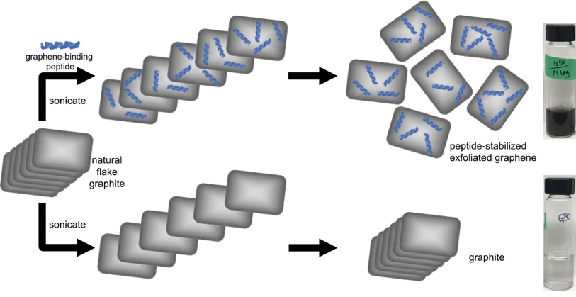
Introduction. Peptide-based methods represent unique approaches for the production and assembly of functional nanocomposite materials. While great advances have been made with peptides binding and stabilizing colloidal suspensions of zero dimensional spherical nanoparticles, their application and use on two dimensional (2D) nanosheet structures such as graphene and h-BN remain understudied. Peptides could provide unique handles for binding to the 2D nanosheet surface, including the deposition of secondary molecules at the interface of the nanosheets, as well as exfoliation of individual sheets from bulk stacked structures under ambient and sustainable conditions. In this talk, I will focus on our research probing the binding and use of graphene and h-BN specific peptides to their target materials, which can be exploited for the exfoliation of individual sheets in water at room temperature.

Methods. Commercially sourced graphene and h-BN binding peptides were modified to incorporate a C₁₀ fatty acid chain at either the N- or C-terminus via thiol/maleimide coupling. The peptides were subsequently examined for binding at the target interface via quartz crystal microbalance (QCM) analysis and atomic force microscopy (AFM). Additional spectroscopic characterization was also completed and was complemented by computational simulation. The peptides were further used to exfoliate individual graphene sheets from bulk graphite, which was achieved using bath sonication in water. The final materials were fully characterized through a series of spectroscopic and microscopy-based analysis methods.

Results and Discussions. The results demonstrated significant affinity from the h-BN and graphene binding peptides to their target materials. Once bound, the peptides arranged in a specific morphology at the nanosheet interface, as imaged by AFM. In general, changes in the peptide overlayer structure were achieved based upon the biomolecule solution concentration, sequence, nanosheet composition, and binding reaction time. In addition, this overlayer morphology and the bound peptide structure were significantly altered based upon the incorporation of a fatty acid into the biomolecule. Once the binding event was quantified, the peptides were exploited for the exfoliation of individual nanosheets from bulk layered structures. This was achieved in water using simple bath sonication of bulk graphite powder in the presence of the graphene-binding sequences. Highly stable graphene sheets were produced from this approach, including few layered structures, where changes in the number of defects incorporated into the final 2D nanosheets was accessed based upon the incorporation of the fatty acid into the peptide. To this end, the fatty acid domain of the biomolecule was able to wrap the graphene edge, thereby diminishing defect incorporation at this region.

Conclusion. In summary, peptide-based methods for the production of stable 2D nanosheet materials in water was achieved. These peptides bind to the material surface, generating an overlayer morphology that was dependent upon numerous parameters. This binding event was exploited for the exfoliation of individual graphene sheets from bulk graphite. Such results pave the way for the use peptides to both exfoliate nanosheets and eventually controllably assemble these materials into complex heterostructures based upon the affinity of the biomolecules.

