Photonic devices in single crystal (111) diamond membrane
Blake Regan¹, Aleksandra Trycz¹, Kerem Bray¹, Carlo Bradac¹, Milos Toth¹, Sejeong Kim¹, Igor Aharonovich¹
¹School of Mathematical and Physical Sciences, University of Technology Sydney, Ultimo, NSW, 2007, Australia
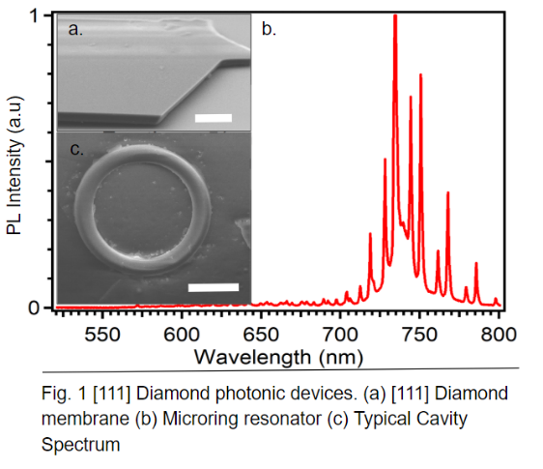
Introduction. Diamond Colour centers have consistently proven to be an attractive building block for integrated quantum photonics. Furthermore, as a host material, diamond boasts a wide transmission band (ultraviolet to infrared) and having a high mechanical strength and thermal conductivity¹. The SiV Colour enter boasts a narrow zero phonon line at 738nm containing ~70% of emission, and SiV inversion symmetry which reduces the effect of strain and electromagnetic fluctuations. For applications requiring photon indistinguishability such as quantum communication and information processing, these properties are desirable. Taking full advantage of these colour enters is therefore paramount for their applicability in these fields. The SiV Colour center has both a physical and dipole orientation in the [111] orientation, meaning an enhancement to the directionality of emission both out and into plane.

Aims. In this work we demonstrate high quality, thin diamond films with Embedded colour centres within a single crystal of [111] orientation². To achieve this goal, optically active thin membranes are essential as they are the primary building block of photonic components such as microcavities, photonic crystal cavities, resonators and waveguides³.

Methods. The diamond membranes are generated using ion implantation and electrochemical liftoff of a [111] faceted CVD overgrown commercial diamond (Fig1.a) . The lifted off membrane is overgrown in a Microwave Plasma Chemical Vapour Deposition system (MPCVD) in the presence of Silicon. The original material was removed by Inductively Coupled Plasma - Reactive Ion Etching (ICP-RIE). A hydrogen silsesquioxane (HSQ) hard mask was deposited on the membrane and an array of microring cavities were patterned using Electron Beam Lithography (EBL), and transferred using O2 ICP-RIE (Fig1.b). The mask is removed by SF6 RIE. To study the optical properties of the diamond membranes, photoluminescence (PL) measurements were taken under a continuous-wave 532 nm laser excitation at room temperature (Fig1.c).

Results and Discussion. PL and electron back scatter (EBSD) of CVD overgrowth produced single crystal growth show a homogenous distribution of SiV emitters in a single crystal [111] membrane. SEM image of the diamond surface further exhibit a smooth surface and clear crystal facets. A comparative study of a [111] and [100] membrane shows [111] membranes to have superior intensity and homogeneity SiV. The fabricated diamond Ring resonators exhibit Q factors up to ~2500. The SiV emission shows a 25x enhancement between its on and off resonance positions. [100] oriented resonators sowed a significantly lower q factor of 2000 and enhancement of 14x despite similar structure. This difference can be attributed to the in-plane dipole of the SiV emission along the 111 direction.

Conclusion. We have described a robust method of engineering [111] oriented diamond membranes with optically active SiV colour centers. These membranes demonstrate preferable directionality of SiV emission both perpendicular and along the plane. This advantage is demonstrated through the fabrication of optical resonators and compared to a [100]-plane counterpart, showing superior enhancement and q factors.

References
1. Aharonovich, I. & Neu, E. Diamond nanophotonics. Adv. Opt. Mater. 2, (2014).
2. Rogers, L. J. et al. Electronic structure of the negatively charged silicon-vacancy center in diamond. Phys. Rev. B - Condens. Matter Mater. Phys. 89, (2014).
3. Sipahigil, A. et al. An integrated diamond nanophotonics platform for quantum-optical networks. Science (80-. ). 354, (2016).

