**Tumour microenvironment-enhanced layered double hydroxides for synergistic phototherapy and chemodynamic therapy under low power laser irradiation**

*Luyao SunA, Li LiA, Zhi Ping (Gordon) XuA*

AAustralian Institute for Bioengineering and Nanotechnology, The University of Queensland, St Lucia, QLD 4072, Australia

**Introduction**

Photodynamic therapy (PDT) has shown promising in cancer therapy. However, the therapeutic effects are seriously limited by oxygen reliance. Photothermal therapy (PTT) and chemodynamic therapy (CDT) as the oxygen independent treatment modalities can kill tumour cells by local hyperthermia and reactive oxygen species (ROS) generated via Fenton or Fenton-like reactions. In this regard, the combination of PTT, PDT and CDT shows the potential to overcome the restriction and achieve synergistic therapeutic effects.

Fig. 1 Cell viability after treatment with Cu-LDH/ICG NPs under laser irradiation. *Statistically significant, *p* < 0.05.

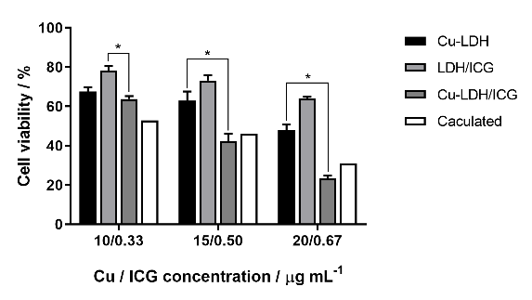

**Aims**

In this study we aim to develop Cu-LDH/ICG NPs as a multifunctional theranostic nanoplatform to achieve three objectives: (1) acid-enhanced photothermal conversion; (2) single low power laser-triggered therapeutic capacity; and (3) synergistic PTT/PDT/CDT.

**Methods**

Cu-doped Mg3Al-LDH/ICG (Cu-LDH/ICG) NPs were prepared using co-precipitation and substitution as previously reported with slight modification1. The PTT, PDT, and CDT performances were evaluated and optimised. Further *in vitro* assessment were conducted using 4T1 mammary carcinoma cells to evaluate cellular performances of the designed LDH particles under 808 nm laser irradiation at a relatively low power.

**Results and Discussion**

The physicochemical characteristics of LDH NPs, including morphology, hydrodynamic diameter, zeta potential, and photostability were evaluated. The particles had a plate-like morphology with the diameter at around 30 nm. They were positively charged with ICG loading efficiency at about 99.5%. The photothermal conversion efficiency of Cu-LDH/ICG particles in deionized water was 50.2% under 808 nm laser irradiation at 0.5 W/cm2, which was significantly increased to 69.2% and 81.5% in pH 6.0 and 5.0 buffers. Moreover, Cu-LDH/ICG NPs showed efficient ROS generation and TME-modulating capacity under laser irradiation. The *in vitro* studies demonstrated the biocompatibility of the designed LDH in dark, whereas the particles exhibited a significant inhibition on the growth of 4T1 cells by hyperthermia and intracellular ROS generation under laser irradiation.

**Conclusion**

In summary, we successfully designed and synthesised multifunctional Cu-doped LDH NPs, which efficiently inhibited the tumour growth via combined PTT/PDT/CDT. The LDH NPs showed a considerable PTT effect with excellent acid-enhanced photothermal conversion with enhanced ICG photostability. The LDH NPs also effectively generated cellular ROS, leading to significant tumour cell death. More importantly, the Cu-LDH/ICG NPs consumed GSH, relieved the antioxidant capability of the tumour and further improved the treatment efficiency. Hence, the combination treatment using Cu-LDH/ICG NPs under low-power laser irradiation appears to be a promising strategy for combination cancer therapy.

**References**

1. Li, B.; Tang, J.; Chen, W.; Hao, G.; Kurniawan, N.; Gu, Z.; Xu, Z. P., Novel theranostic nanoplatform for complete mice tumor elimination via MR imaging-guided acid-enhanced photothermo-/chemo-therapy. Biomaterials 2018, 177, 40-51.