Electrocatalytic nanoparticles that mimic the three-dimensional geometric architecture of enzymes: The importance of nanoscale confinement on electrocatalytic performance

Johanna Wordsworth ^{A}, Tania M. Benedetti ^{A}, Ali Alinezhad ^{A}, Richard D. Tilley ^{A, B}, Martin A. Edwards^{C}, Wolfgang Schuhmann ^{D}, J. Justin Gooding^{A, E} (justin.gooding@unsw.edu.au)
^{A}School of Chemistry and Australian Centre for NanoMedicine, UNSW, Sydney 2052, Australia; ^{B}Electron Microscope Unit, Mark Wainwright Analytical Centre, UNSW, Sydney 2052, Australia; ^{C}Department of Chemistry, University of Utah, Salt Lake City, UT 84112, United States; ^{D}Analytical Chemistry - Center for Electrochemical Sciences (CES), Faculty of Chemistry and Biochemistry, Ruhr-Universitat ̈ Bochum, Universitatsstr. 150, D-44780 Bochum, Germany ̈; ^{E}Australian Research Council Centre of Excellence in Convergent Bio-Nano Science and Technology, UNSW, Sydney 2052, Australia.

Introduction.
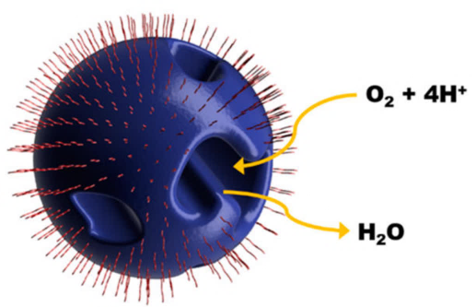
One of the main mechanisms by which enzymes achieve their catalytic efficiency is through the isolation of their reactive centre from the bulk solution in which the substrate is found. Our “nanozyme” nanoparticles mimic the three-dimensional geometry of enzymes for electrocatalysis as a way to increase specific activity for ORR. This is achieved by forming isolated substrate channels that penetrate into the centre of the nanoparticle with an exterior surface electrochemically passivated by a surfactant.¹ The electrochemical reaction is then restricted to occur within a nano-confined substrate channel allowing control over the solution environment.
Fig.1. Schematic illustration of a nanozyme.¹

Aims.
The purpose of this research was to understand how substrate channels affect electrocatalytic performance.

Methods.
Ni-rich domains within PtNi nanoparticles, induced by lattice mismatch, were etched away in acid to give isolated substrate channels with diameters on the order of a couple of nanometers.¹ ORR activity was measured for nanozymes with different substrate channel diameters. Koutecký-Levich plots were used to calculate kinetic current density over a range of potentials in the mixed kinetic-diffusion region. Physicochemical modelling of the electrocatalytic system was then employed to help explain these results.

Results.
Kinetic current density was 3.3 times higher when the surface outside the channels is passivated and is among the highest specific activity reported for Pt-Ni nanoparticles. Narrow channels are more active at low overpotentials (ca. 0.95 V (RHE)), while wider channels exhibit higher activity at higher overpotentials.

Discussion.
Proton and oxygen concentration profiles inside isolated channels showed that nanoconfinement is an unforeseen double-edged sword. Proton concentration is higher within smaller channels, leading to high activity at low overpotentials. As overpotential is increased, oxygen depletion within the small channels is detrimental to activity, resulting in the larger channel nanozymes becoming more active by comparison.

Conclusion.
Electrocatalytic nanoconfinement has the potential to greatly enhance activity by controlling reactant mass transport. This can lead to greater reaction selectivity by controlling the chemistry inside substrate channels.

References
1. Benedetti, T. M.; Andronescu, C.; Cheong, S.; Wilde, P.; Wordsworth, J.; Kientz, M.; Tilley, R. D.; Schuhmann, W.; Gooding, J. J. (2018). Electrocatalytic nanoparticles that mimic the three-dimensional geometric architecture of enzymes: Nanozymes. J. Am. Chem. Soc., 140, 41, 13449-13455.

