Introduction of trace La in to lithium-rich cathode materials towards long-cycling stability
Xiaobo Zhu, Lianzhou Wang
Nanomaterials Centre, School of Chemical Engineering and Australian Institute for Bioengineering and Nanotechnology, The University of Queensland, QLD 4072, Australia
1. Introduction
Lithium ion batteries (LIBs) have received worldwide attention as power sources for electric vehicles (EVs) and portable energy storage. In the current market, the specific capacities of the benchmark cathode materials such as LiCoO₂, LiFePO₄ and LiMn₂O₄ are around 150 mAh/g or less, which however almost reach their theoretical capacity.¹ As a result, it is essential to explore new types of cathode material with higher theoretical capacity to satisfy the requirements of EVs and home energy storage battery (HESB). Among the reported new cathode materials, LRCMs have attracted increasing attention due to their extraordinary high specific capacity both theoretically (>300 mAh/g) and practically (>250 mAh/g) at room temperature, almost twice of that the traditional cathode materials can achieve. Generally, they are described as xLi₂MnO₃·(1-x) LiMO₂ (M = Mn, Ni, Co or their mixture), in which the Li₂MnO₃ can be activated by high voltage charging (> 4.5 V) to provide extra capacity.² In addition, they can offer a high working voltage of 3.6 V or even higher, which could significantly contribute to an ultrahigh energy density of up to 1000 Wh/kg. However, several technical challenges, including voltage fade, large first-cycle capacity loss, poor rate capability, and limited cycle life of LRCMs, remain to be solved prior to commercial application of these cathodes.³
To overcome these challenges, several strategies have been employed to improve the performance of lithium-rich materials. Among the strategies, lattice doping is commonly considered to be an effective method to enhance their electronic conductivity. However, previous reports on the doping of layered lithium-rich materials with Al³⁺, Mg²⁺, Cr³⁺, Ti⁴⁺, etc. showed a limited improvement in electrochemical performance.³ Therefore, the selection of the doping element and the doping amount is of significance in improving electrochemical properties of the lithium-rich materials. In this work, lanthanum (La³⁺) is selected as a dopant to substitute transition metals (TMs) in layered lithium-rich materials, Li_{1.2}Mn_{0.6}Ni_{0.2}O₂. It is considered that the much stronger bond energy of La–O than Mn–O or Ni–O benefits the stability of the bulk layered structure; meanwhile, doping La³⁺ ions with a “super-large” radius (rLa³⁺ = 0.1032 nm) vs.Mn⁴⁺ ions (rMn⁴⁺ = 0.053 nm) is expected to expand Li⁺ pathways in this layered structure.
2. Methodology
LRCMs, Li_{1.2}Mn_{0.6-3x/4}Ni_{0.2-x/4}La_{x}O₂ (x = 0, 0.002, 0.004, and 0.006), were synthesized by a polymer-assisted sol-gel method. To prepare the materials, stoichiometric amounts of metal salts (nickel acetate, manganese acetate, lithium acetate and lanthanum acetate) were dissolved in distilled water, followed by the introduction of acrylic acid. The mixture was stirred on hotplate until a dry gel formed. Then the dried gel was heated to 450 °C to get precursors. After being ground into powders, the precursors were calcined at 850 °C in air for 10 h.
Then the as-prepared materials were subjected to general and electrochemical characterization.
3. Results and Discussion
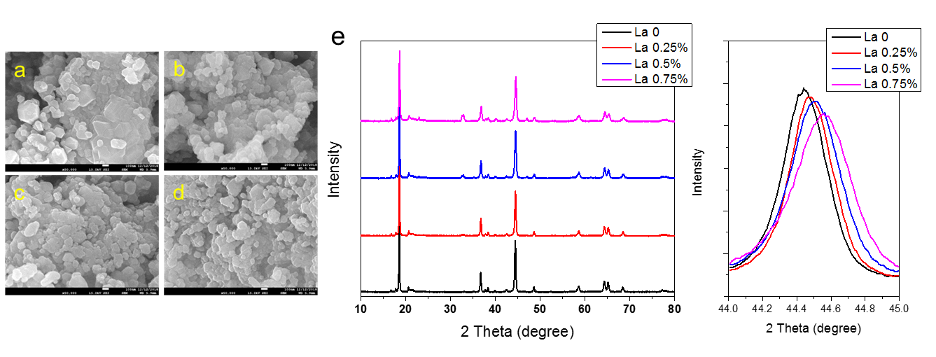
Figure 1 (a-d) SEM images and XRD patterns (e) of the Li_{1.2}Mn_{0.6-3x/4}Ni_{0.2-x/4}La_{x}O₂ (x = 0, 0.002, 0.004, and 0.006) samples.

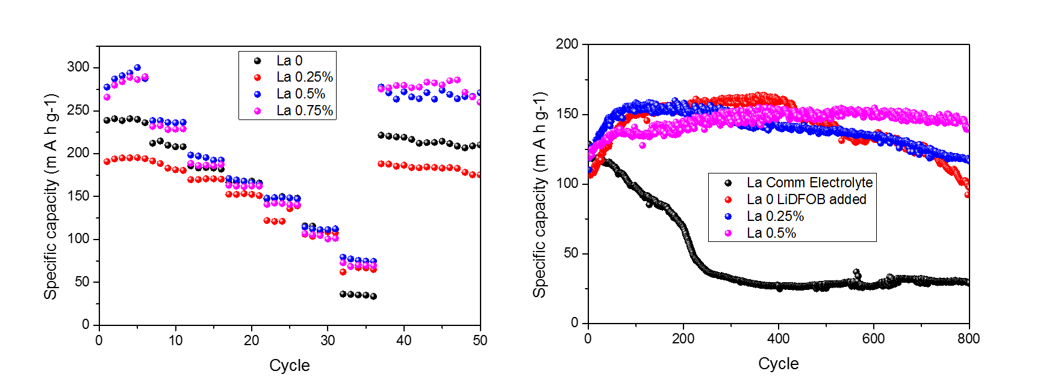
Figure 2 Rate and cycling performance of the LRCMs containing different amounts of La³⁺.
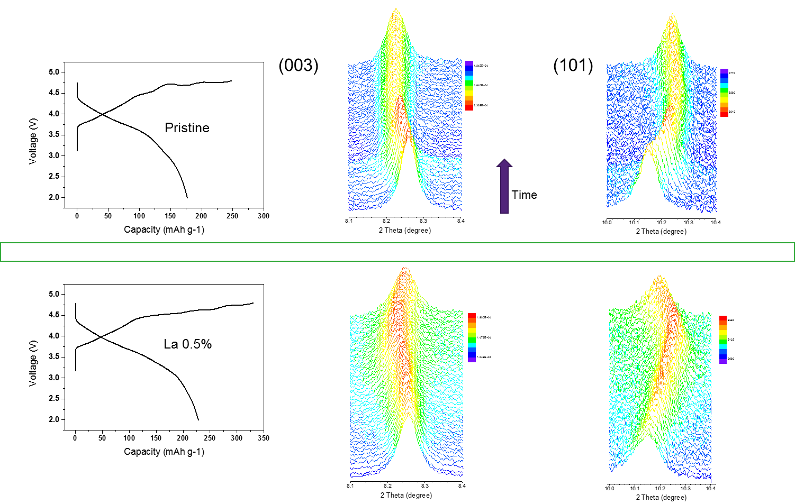
Figure 2 Comparison of the in-situ evolution of synchrotron diffraction peaks before and after La doping.
4. Conclusions
A series of La-contained LRCMs have been synthesized and evaluated. It is clearly demonstrated that a trace amount of La (~0.5% atomic ratio with respect to total transition metal ions) leads to stable high capacities. All the electrochemical enhancement of the La³⁺-introduced materials are associated with the strong La–O bond can stabilize the bulk layered structure and a small amount of the perovskite phase derived after excess doping can possibly protect the particles from electrolyte-erosion as well as maintain oxygen and Li⁺ vacancies.
Acknowledgements
Funding supports from ARC through its LP and DP programs and BAJC Research and Development project are acknowledged.

References
- L. Croguennec, M. R. Palacin, J. Am. Chem. Soc., 2015, 137, 3140.
- M. M. Thackeray, S.-H. Kang, C. S. Johnson, J. T. Vaughey, R. Benedek, S. Hackney, J. Mater. Chem., 2007, 17, 3112.
- J Zheng, S Myeong, W Cho, P Yan, J Xiao, C Wang, J Cho, J Zhang, Adv. Energy Mater. 2017, 7, 1601284.

