Suppression of Spectral Diffusion by Anti-Stokes Excitation of Quantum Emitters in Hexagonal Boron Nitride

Toan Trong Tran,^{1*} Carlo Bradac, ¹ Alexander S. Solntsev, ¹ Milos Toth, ¹ and Igor Aharonovich¹
¹School of Mathematical and Physical Sciences, University of Technology Sydney, Ultimo, NSW, 2007, Australia.
Email: trongtoan.tran@uts.edu.au

Abstract
Solid-state quantum emitters are garnering a lot of attention due to their role in scalable quantum photonics. A notable majority of these emitters, however, exhibit spectral diffusion due to local, fluctuating electromagnetic fields. In this work, we demonstrate efficient Anti-Stokes (AS) excitation of quantum emitters in hexagonal boron nitride (hBN), and show that the process results in the suppression of a specific mechanism responsible for spectral diffusion of the emitters.¹ We also demonstrate an all-optical gating scheme that exploits Stokes and Anti-Stokes excitation to manipulate spectral diffusion so as to switch and lock the emission energy of the photon source. In this scheme, reversible spectral jumps are deliberately enabled by pumping the emitter with high energy (Stokes) excitation; AS excitation is then used to lock the system into a fixed state characterized by a fixed emission energy. Our results provide important insights into the photophysical properties of quantum emitters in hBN,²⁻⁴ and introduce a strategy for controlling the emission wavelength of quantum emitters.

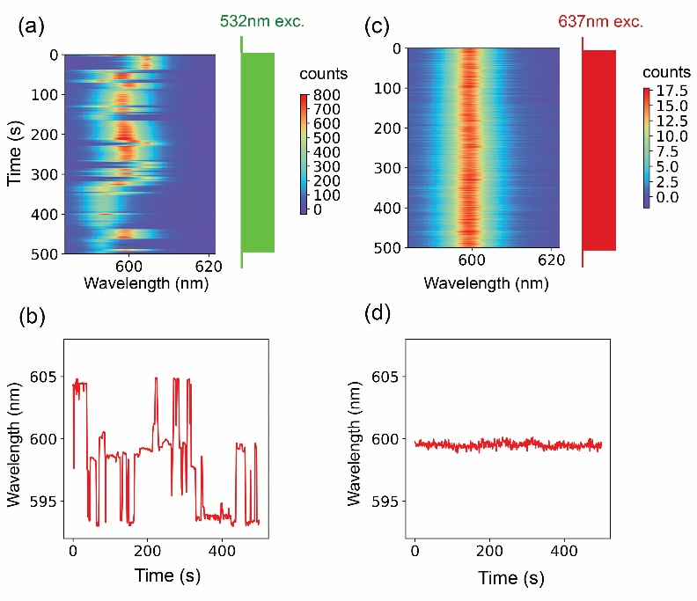
Figure. PL time series of the emitter taken with (a) 532-nm excitation at 900 µW (Stokes excitation) and (c) 637-nm excitation at 5.6 mW (Anti-Stokes excitation). The integration time in (a) and (c) is one-second. The PL spectra were fitted with a single Lorentzian line profile. b, d) Plot of ZPL wavelength versus time extracted from experiments in (a) and (c), respectively. While Stokes excitation induces frequent spectral jumps, Anti-Stokes excitation results in reduced probability for spectral jumps to occur despite the use of a much higher excitation power.
References
1. T. T. Tran, C. Bradac, A. S. Solntsev, M. Toth and I. Aharonovich, arXiv preprint arXiv:1902.03711 (2019).
2. T. T. Tran, K. Bray, M. J. Ford, M. Toth and I. Aharonovich, Nat. Nanotechnol. 11 (1), 37-41 (2016).
3. T. T. Tran, C. Elbadawi, D. Totonjian, C. J. Lobo, G. Grosso, H. Moon, D. R. Englund, M. J. Ford, I. Aharonovich and M. Toth, ACS Nano 10 (8), 7331-7338 (2016).
4. T. T. Tran, C. Zachreson, A. M. Berhane, K. Bray, R. G. Sandstrom, L. H. Li, T. Taniguchi, K. Watanabe, I. Aharonovich and M. Toth, Phys. Rev. Appl. 5 (3), 034005 (2016).

