Layered materials for energy conversion: reactivity and stability
Nasir Uddin^{A}, Ziyang Lu^{A}, Yaping Du^{B}, Zongyou Yin^{A}

^{A}Research School of Chemistry, Australian National University, ACT 2601, Australia
^{B}School of Materials Science and Engineering, Center for Rare Earth and Inorganic Functional Materials, Nankai University, Tianjin 300350, China

Introduction
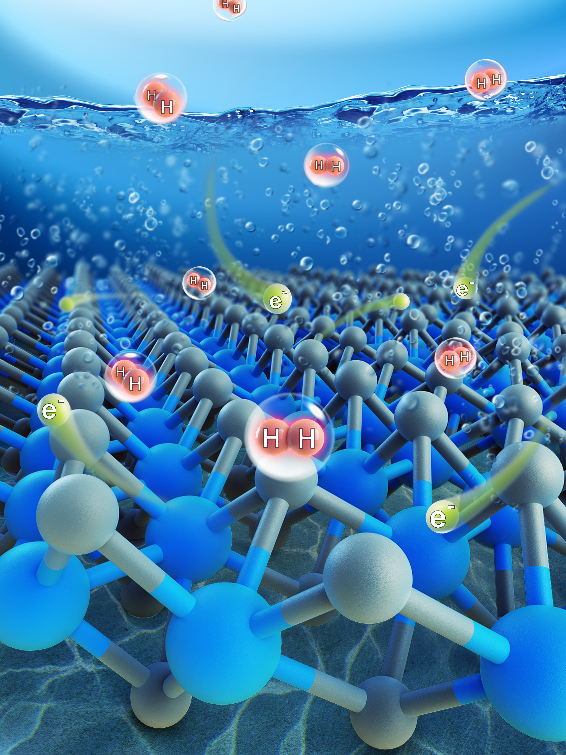Hydrogen as a clean fuel has always been attracting researchers’ intense interest. Most research up to date are more interested in the performance/reactivity. However, in terms of practical application, the stability is equally important as performance. This talk will share some research on both reactivity and stability study from our research groups.

Aims
To study the performance and its stability

Methods
Electrocatalytic and photocatalytic redox reactions based on
layered materials.

Results
First, 1T’-WS2 electrocatalytic hydrogen evolution reaction (HER) shows stable activity at first but degradation appeared after long time reaction induced by mechanical loss and oxidation; Second, transition metal based composites show encouraging photocatalytic nitrogen fixation reactivity when the crystallization degree decreased. The received performance of nitrogen reduction reaction (NRR) is stable and recoverable in the accumulative 20-hour operation period.

Discussion
Nano science and technology offer a vast and fascinating playground to explore the novel physiochemical properties of nanomaterials with the development for various applications including energy conversion and storage. In the research of 1T’-WS2 based nano electrocatalysis, surface molecular tunable crystal phase engineering was developed towards the stable electrocatalytic HER, where the stability was finally interrupted by H₂ bubbling and air oxidation. In the transition metal based composites for photoredox NRR, the crystallization degree control is critical to tune the reactivity and the low-crystallized composites showed stable and recoverable NRR performance in the accumulative 20-hour operation period.

Conclusion
Layered materials with rich engineerable parameters provide a new avenue to enhance the functional efficiency and extend the performance stability for new energy technologies. This talk highlights the synergistic materials science and engineering can provide the opportunities to customize nanomaterials for advanced energy-conversion technology development.

References
- Liu, Z., Li, N., Su, C., Zhao H., Xu L., Yin, Z., Li, J., & Du Y. (2018). Nano Energy, 50, 176.
- Submitted (2019).

