Converting Brown to Green:
Novel Functional Materials from Victorian Brown Coal

*Mehrdad Parsa and Alan L Chaffee

School of Chemistry, 17 Rainforest Walk, Monash University, VIC 3800, Australia

Introduction
Victorian brown coal (VBC) has inherently high moisture and oxygen contents (approx 60 wt% and 25-30 wt%, dry ash free basis, respectively). These properties are responsible for its high CO2 emissions when combusted as a fuel. VBC is, however, also one of the cleanest coals in the world, on account of its very low ash, nitrogen and sulfur contents. These properties make it a very suitable precursor for carbonaceous products.
The research output
We have recently developed a facile low-cost and high-yield method for the preparation soluble and insoluble Carbon Quantum Dots (CQDs) directly from VBC (Fig 1 a). The produced CQDs exhibit good quantum yields (2.5- 6%) and photoluminescence behaviour, which can be readily tuned to variable wavelengths. By changing the production condition, two types of CQD’s with different photoluminescence behavior have been produced (Fig. 1 b and c). The main advantages of this novel production method include: the easy large-scale synthesis, environmentally friendly (doesn’t use oxidation agents such as strong acids), the available and inexpensive carbon precursor. So far, CQD production are mostly carried out at small scale (grams). This approach may offer the potential for larger production quantities and facilitate industrial application.
CQDs are desirable in many applications such as bio-imaging, drug delivery, optronics, chemical sensing and photocatalysis, because of their low toxicity, chemical stability and biocompatibility.
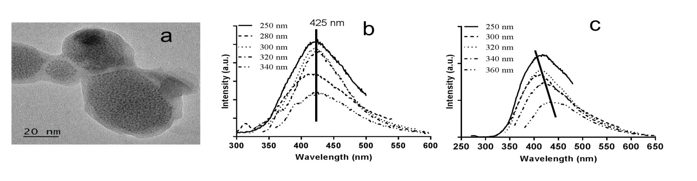
Figure 1. a) TEM image of CQDs, b) CQD with independent emission wavelength and c) CQD with dependent emission wavelength to excitation wavelength

