Ultrasensitive thermal sensing technology utilising SiC/Si nanoheterojunction

Toan Dinh^{A}, Thanh Nguyen^{A}, Abu Riduan Md Foisal^{A}, Hoang-Phuong Phan ^{A}, Tuan-Khoa Nguyen ^{A}, Nam-Trung Nguyen ^{A}, Dzung Viet Dao ^{A,B}
^{A}Queensland Micro and Nanotechnology Centre, Griffith University, Queensland, AUSTRALIA.
^{B}School of Engineering and Built Environment, Griffith University, Queensland, AUSTRALIA

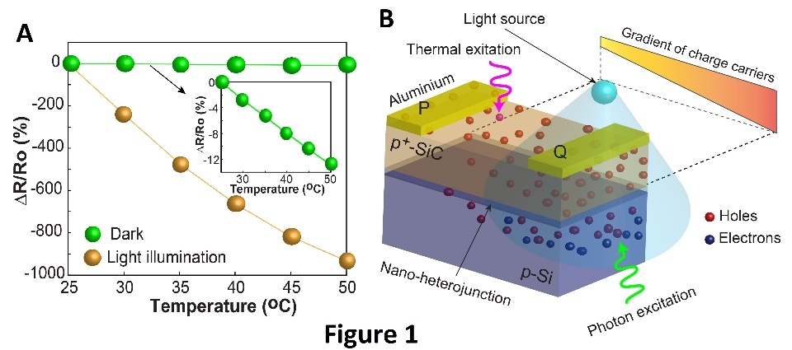
Introduction. Detection and mediation of temperature is of considerable interest in industrial processes, laboratory as well as daily life activities^{1,2}. Over the past century, tremendous progress has been made in the development and commercialisation of temperature sensing devices including resistive temperature detectors (RTD)5 and thermistors³. These devices employ the electrical resistance change versus temperature variation to define TCR as an indicator for the temperature sensitivity. The development of advanced sensing technologies, which can significantly enhance the sensing performance of conventional solid-state devices by manipulating the generation and transport of charge carriers, is desirable for a wide range of sensing applications.
Aims. This work aims to develop a new thermal sensing concept to enhance the performance of thermal sensing nanodevices. Manipulating thermal excitation and transport of charge carriers in nanoheterojunctions, we demonstrate here a giant temperature sensing effect via optoelectronic coupling in semiconductor nanofilms.
Methods. We utilized silicon carbide (SiC) nanofilms that formed nano-heterojunctions on silicon (Si). A 280 nm-thick single crystalline 3C-SiC film was grown on a p-type (100) Si substrate by low pressure chemical deposition (LPCVD) at a temperature of 1000ºC. We used a heater in an enclosed chamber to control the device temperature while uniform light was employed to generate the voltage between two electrodes of the SiC device. A gradient of charge carriers in the nanofilms under non-uniform light illumination is coupled with an electric tuning current to enhance the performance of the thermal sensing effect.
Results. Figures 1A show the relative resistance change vs temperature variation and TCR of p⁺-SiC/p-Si under light illumination (2,000 lux) compared with those measured under darkness. At 50ºC, the relative resistance change under light conditions (ΔR/Ro)_{light} was measured with an increase of up to 1,000% when the temperature increases from the room temperature to 50ºC. The increment of the resistance ratio between light and dark conditions (ΔR/Ro)_{light}/(ΔR/Ro)_{dark} was clearly observed to be approximately 100 times at 50ºC. The corresponding temperature coefficient of resistance (TCR) was measured to be -0.5%/K at darkness while it increased to approximately -50%/K under uniform light conditions.
Discussion. The enhancement reflects the significant contribution of the photovoltage gradient generated in the SiC nanofilm under light illumination (Figure 1B). This increment indicates that the ultrasensitive temperature sensing effect of the p⁺-SiC/p-Si nanoheterojunction is achievable by manipulating light conditions and electric field/current. The results demonstrate the remarkable advance of the temperature sensing technology based on the coupling of the tunning current, the lateral photoelectricity and thermal excitation of charge carriers in the nanoheterojunction.
Conclusion. We demonstrated a novel ultrasensitive thermal sensing technology based on the optoelectronic coupling effect in the nanoheterojunction. The coupling of the photon excitation in the p⁺-SiC/p-Si heterostructure and the electric tuning current was to manipulate the thermal excitation of charge carriers in SiC nanofilms, resulting in a giant temperature sensing effect
References
- Feteira, A., 2009. Journal of the American Ceramic Society, 92, 967-983.
- Trung, T.Q., Ramasundaram, S., Hwang, B.U. and Lee, N.E., 2016. Advanced materials, 28, 502-509.
- Dinh, T., Phan, H.P., Qamar, A., Woodfield, P., Nguyen, N.T. and Dao, D.V., 2017. JMEMS, 26, 966-986.

