Vortex fluidics assisted in-situ Small Angle Neutron Scattering for nano-encapsulation of fish oil formulation and its applications
Nikita Joseph^{A}, Shan He^{A,B}, Marzieh Mirzamani^{C}, Harshita Kumari^{C}, Colin L. Raston^{A}
^{A}Flinders Institute for Nanoscale Science and Technology, College of Science and Engineering, Flinders University, Bedford Park, SA 5042, Australia
^{B}Department of Food Science and Engineering, School of Chemistry Chemical Engineering, Guangzhou University, 510006, China
^{C}James L. Winkle College of Pharmacy, University of Cincinnati, Cincinnati, OH 45267-0004, USA
A green and facile microfluidic process has been developed for the encapsulation of fish oil emulsions using a thin film vortex fluidic device (VFD) operating under continuous flow, allowing control over the droplet sizes and the stability of the processed emulsions (Fig.1). The encapsulated particles range in diameter from 100 to 200 nm. This microfluidic platform simplifies the processing procedure of encapsulation into a time- and cost-saving one-step process devoid of any organic solvents, in contrast to the conventional homogenization process, which is inherently complex and involves multiple steps and the use of organic solvents. Oxidation of the fish oil was significantly reduced from 38.33% (69.28% to 30.95% using homogenization) to 6.67% (69.28% to 62.61% using VFD), as evidence for the high stability of the encapsulated particles. This stability and attenuated oxidation is consistent with the VFD-encapsulated fish oil enriching the omega-3 fatty acid content of apple juice and other water-based food products without changing their sensory values. The VFD-encapsulated fish oil system serves as a suitable model for producing homogenous suspensions of water-insoluble bioactive molecules, as established for curcumin and quercetin which have encapsulation capacities of 20.49 mg, and 15.36 mg, in 1 g of fish oil, respectively. The new processing represents an alternative bottom-up approach to single-step benign processing, as a versatile scalable process for downstream applications. Moreover, in understanding the behavior of the self-assembly and overall stability of the emulsions of the carbohydrate polymer non-ionic surfactant, polysorbate 20 (Tween 20), we have developed an in situ real time Small Angle Neutron Scattering (SANS) characterization technique.

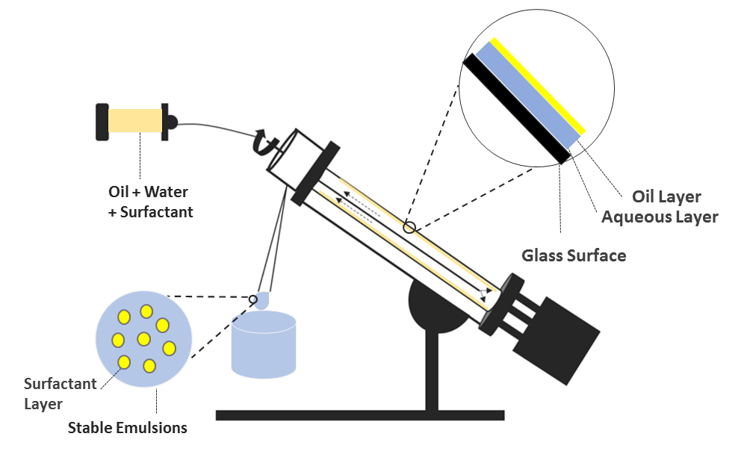
Figure 1: Schematic representation of the Vortex Fluidic Device (VFD) processing emulsions.

References
- Britton, J. , & Raston, C. L. (2017). Multi-step continuous-flow synthesis. Chemical Society Reviews, 46(5), 1250.
- He, S., Joseph, N., Luo, X. & Raston, C. (2019). Continuous flow thin film microfluidic mediated nano-encapsulation of fish oil. LWT-Food Science and Technology, 103, 88-93.
- Xuan, L., Smith, P., Raston, C.L., & Zhang W. (2016). Vortex fluidic device-intensified aqueous two phase extraction of C-phycocyanin from spirulina maxima. ACS Sustainable Chemistry & Engineering, 4(7). 3905-3911.

