Nature-inspired protection of highly sensitive 2D materials against ambient oxidation

Vipul Bansal^{A}

^{A}Ian Potter NanoBioSensing Facility, NanoBiotechnology Research Laboratory, School of Science, RMIT University, Melbourne, VIC, 3000, Australia. E-mail: Vipul.Bansal@rmit.edu.au

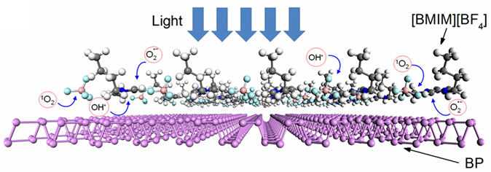
Fig. 1. A schematic representation of [BMIM][BF4] ionic liquid-induced sequestration of reactive oxygen species (ROS) on the phosphorene surface to avoid its degradation under ambient conditions.

Recent developments have seen a keen interest in 2D materials for a variety of applications [1]. However, the high reactivity of some of these materials in ultrathin morphologies has posed challenges in keeping them stable enough for deployment in practical devices. Few-layer black phosphorous (BP), commonly known as phosphorene, is one of such materials that face rapid ambient degradation (Fig. 1). The most common strategies employed to protect BP have relied upon preventing its direct exposure to the environment which has practical challenges. Motivated by these observations, our work has attempted to understand the mechanisms of photo-oxidative damage to BP [2, 3], and has tried to identify biological processes through which nature overcomes the issues of photooxidative insults. These insights have allowed us to develop a new approach that permits photosensitive 2D materials to remain stable without requiring their isolation from the ambient environment [4]. In particular, our work draws inspiration from the unique ability of the biological systems to avoid photo-oxidative damages caused by reactive oxygen species (ROS) by utilising antioxidant pathways. Since BP and other 2D materials undergo similar photo-oxidative degradation, we could employ imidazolium-based ionic liquids as quenchers of these damaging species on the BP surface (Fig. 1). This chemical sequestration strategy allowed BP to remain stable for over three months while retaining its key electronic characteristics. This study opens opportunities to practically implement BP and other environmentally-sensitive two-dimensional (2D) materials for next-generation opto-electronic applications.

References
- S. Kuriakose, T. Ahmed, S. Balendhran, et al., 2D Materials, 2018, 5, 032001.
- T. Ahmed, S. Balendhran, Md. N. Karim, et al., npj 2D Materials and Applications, 2017, 1, 18.
- S. Walia, Y. Sabri, T. Ahmed, et al., 2D Materials, 2017, 4, 015025.
- S. Walia S. Balendhran, T. Ahmed, et al., Advanced Materials, 2017, 29, 1700512.

