Novel Plasmonic Nanomaterials for Near Infrared Light Energy Conversion

Toshiharu Teranishi

Institute for Chemical Research, Kyoto University, Uji, Japan.

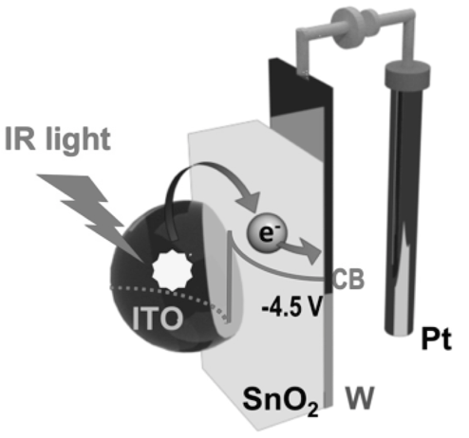
The structure of nanomaterial determines their individual properties and assembled structures they can form [1,2]. Highly efficient photoenergy conversion in heterostructured nanoparticles (HNPs) requires the formation of epitaxial heterointerfaces and band alignment engineering. One of the phases in HNPs should hold the light absorbing ability, such as narrow band gap semiconductor [3-7] and plasmonic material [8-10]. Special attention has been given to the HNPs with the combination of plasmonic semiconductor/semiconductor [8-10], where the near infrared plasmon-induced carrier transfer takes place to realize the long-lived charge separation and near infrared light energy conversion into electricity (see Fig. 1) [9] and chemical energy [8-10].
Fig. 1 Near infrared light energy conversion into electricity in ITO/Sn₂O system [9]

References
- Wu, H.-L. et al. (2016). Formation of pseudomorphic nanocages from Cu₂O nanocrystals through anion exchange reactions. Science, 351, 1306-1310.
- Kanehara, M. et al. (2012). Large-scale synthesis of high-quality metal sulfide semiconductor quantum dots with tunable surface-plasmon resonance frequencies. Chem. Eur. J., 18, 9230-9238.
- Saruyama, M. et al. (2011). Spontaneous formation of wurtzite-CdS/zincblende-CdTe heterodimers through a partial anion exchange reaction. J. Am. Chem. Soc., 133, 17598-17601.
- Sakamoto, M. et al. (2014). Investigation on photo-induced charge separation in CdS/CdTe nanopencils. Chem. Sci., 5, 3831-3835.
- Teranishi, T. et al. (2013). Charge separation in type-II semiconductor heterodimers. J. Phys. Chem. Lett., 4, 2867-2873. (Perspective)
- Sakamoto, M. et al. (2016). Light-stimulated carrier dynamics of CuInS2/CdS heterotetrapod nanocrystals. Nanoscale, 8, 9517-9520.
- Kawawaki, T. et al. (2019). Carrier-selective blocking layer synergistically improves the plasmonic enhancement effect. J. Am. Chem. Soc., 141, 8402-8406. (Cover picture)
- Lian, Z. et al. (2018). Near infrared light induced plasmonic hot hole transfer at a nano-heterointerface. Nat. Commun., 9, 2314.
- Sakamoto, M. et al. Clear and transparent nanocrystals for infrared-responsive carrier transfer. Nat. Commun., 10, 406.
- Lian, Z. et al. Plasmonic p-n junction for infrared light to chemical energy conversion. J. Am. Chem. Soc., 141, 2446-2450. (Cover picture)

