Environmental Photoelectron Yield Spectroscopy

John A Scott, Igor Aharonovich and Milos Toth
School of Mathematical and Physical Sciences, University of Technology Sydney, Ultimo, Australia

Introduction.
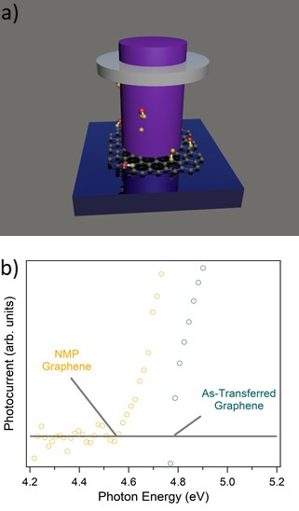
Photoemission yield spectroscopy (PYS) provides a direct measurement of the occupied electronic states in a material.¹ This surface characterisation technique is commonly used to study band edge positions and defect energy levels in an ultra high vacuum environment. Environmental photoemission yield spectroscopy (EPYS) extends these capabilities to low vacuum pressures, enabling real time characterisation of surface states in reactive gaseous environments (Figure 1a).
Figure 1a) Schematic showing EPYS characterization of single-layer graphene. b) Photoemission yield spectra of graphene before and after chemical doping by NMP.

Results.
Here, we have investigated surface-adsorbate interactions– including the chemical doping of graphene–as well has the electron amplification process that occurs in a gas.^{2,3,4} Figure 1b shows a shift in the photoemission threshold energy of graphene in the presence of NMP due to electron charge transfer. The results provide powerful insight into chemical doping of 2D materials. High sensitivity is able to be achieved by gas cascade amplification of the photocurrent. Gas cascade amplification plays an important role in both environmental scanning electron microscopy and EPYS. We further show that the EPYS system can be used to measure gas cascade amplification efficiency and identity ethanol as a superior imaging gas.⁴

Conclusion.
The work presented here identifies EPYS as an important tool for measuring the occupied electronic states of surfaces including 2D materials and understanding the electron amplification process critical to widely used characterization techniques.

References
1. Sebenne, C., (1977) High-resolution photoemission yield and surface states in semiconductors. Il Nuovo Cimento B 39(2),768-780
2. Shanley, T., Martin, A., Aharonovich, I. & Toth, M. (2014). Localized chemical switching of the charge state of nitrogen-vacancy luminescence centers in diamond. Appl. Phys. Lett., 105, 063103
3. Xu, Z., Mendelson, N., Scott, J., Li, C., Aharonovich, I. & Toth, M., (2019) Charge transition levels of quantum emitters in hexagonal boron nitride (submitted)
4. Shanley, T., Bonnie, F., Scott, J., & Toth, M. (2016) Role of Gas Molecule Complexity in Environmental Electron Microscopy and Photoelectron Yield Spectroscopy ACS Appl. Mater. Interfaces 8, 40, 27305-27310

